How to Invite your friends to like our SNP Twitter account
- Go to our Twitter page https://twitter.com/GaDOENutrition
- On the top right hand side, click on the ‘…’ in the circle
- A pop up will appear, click on ‘Share @GaDOENutrition’
- It will open up a Message screen. Add your friends’ addresses and hit Send.
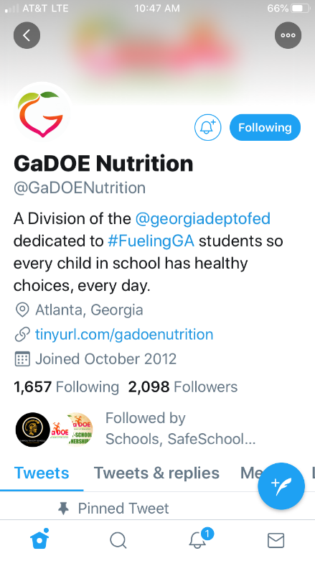 | 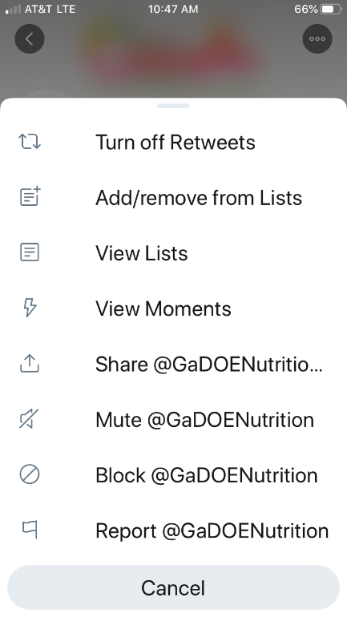 | 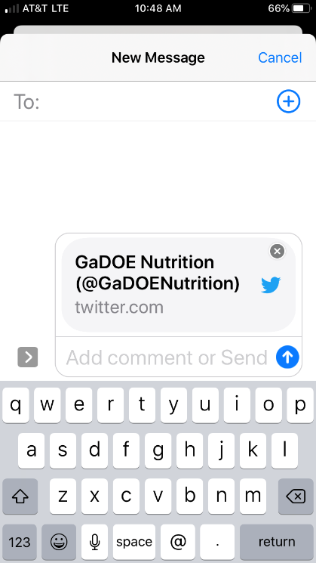

DON’T FORGET!
Use @GaDOENutrition to tag us on Twitter when you post something about SNP!
Always include #fuelingGA as part of your social media posts.

