How to Invite your friends to like our SNP Instagram account
- Go to our Instagram page https://instagram.com/gadoe_snp
- On the top right hand side, click on the ‘’
- A pop up will appear, click on ‘Copy Profile URL’
- Open up a Messenger screen. Hold your finger on the message area and Paste will pop up.
- Paste the Profile address
- Add your friends’ addresses and hit Send.
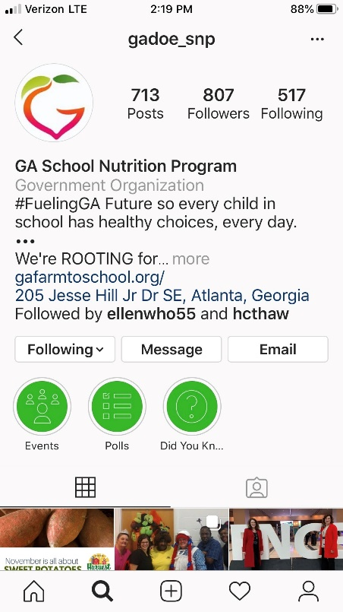 | 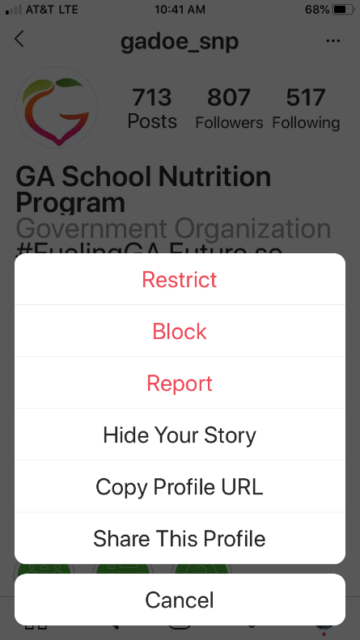 | 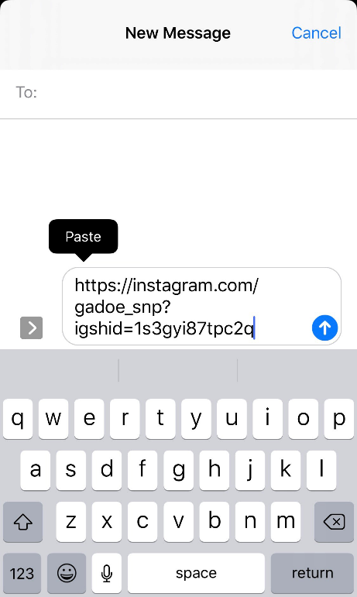

DON’T FORGET!
Use @GaDOENutrition to tag us on Twitter when you post something about SNP!
Always include #fuelingGA as part of your social media posts.

