How to Invite your friends to like our SNP Facebook page
- Go to our Facebook page https://www.facebook.com/gadoenutrition
- On the right hand side, under COMMUNITY, click on “Invite your friends to like this page”.
You may need to scroll over to the right to see COMMUNITY (see screenshots below).
- A pop up will appear, click on “Select All’ or check on individual friends.
- Click “Send Invites”.
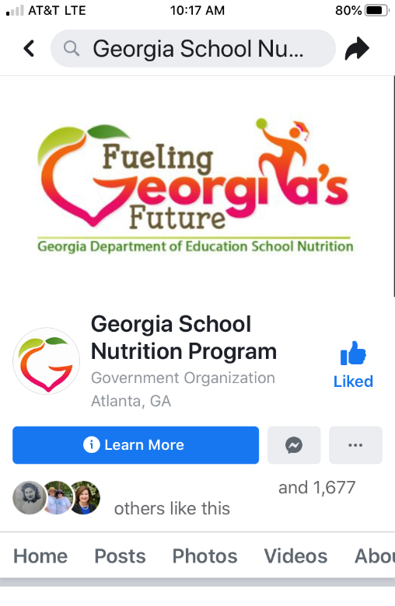  Initial screen. If you don’t see COMMUNITY scroll to the left… | 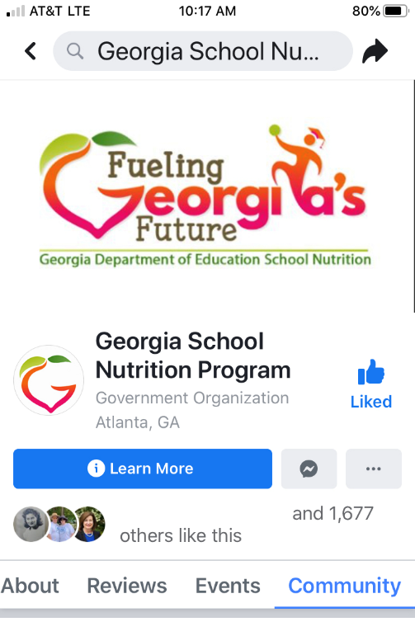 | 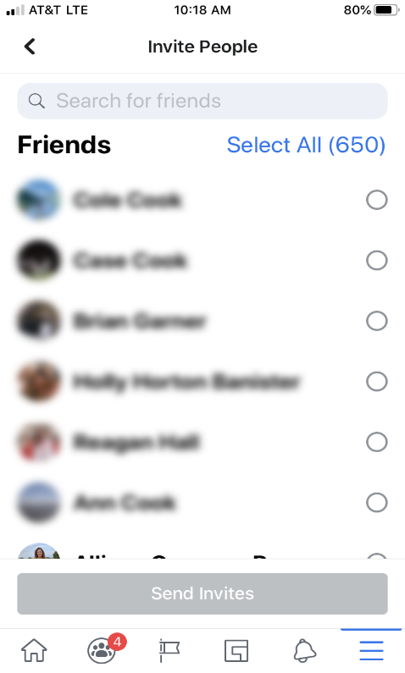

DON’T FORGET!
Use @GaDOENutrition to tag us on Facebook when you post something about SNP!
Always include #fuelingGA as part of your social media posts.

