<< ENTER SCHOOL OR DISTRICT NAME
AND/OR LOGO HERE >>
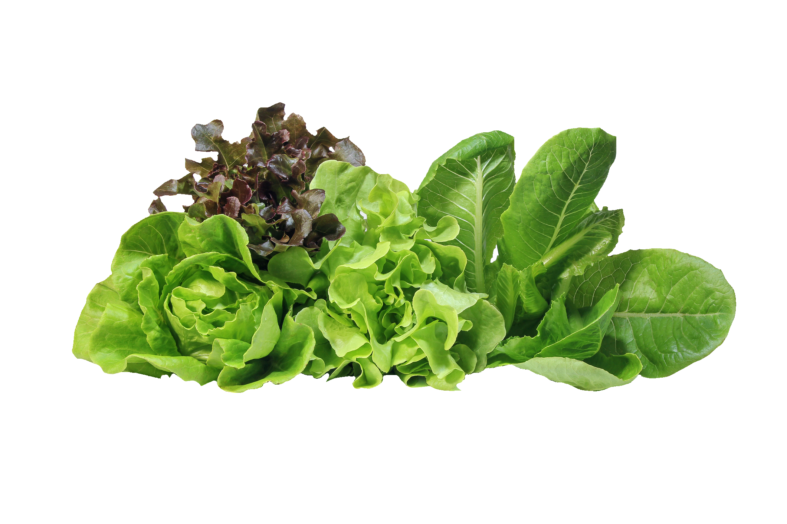
is proud to serve Georgia grown
lettuce in December

