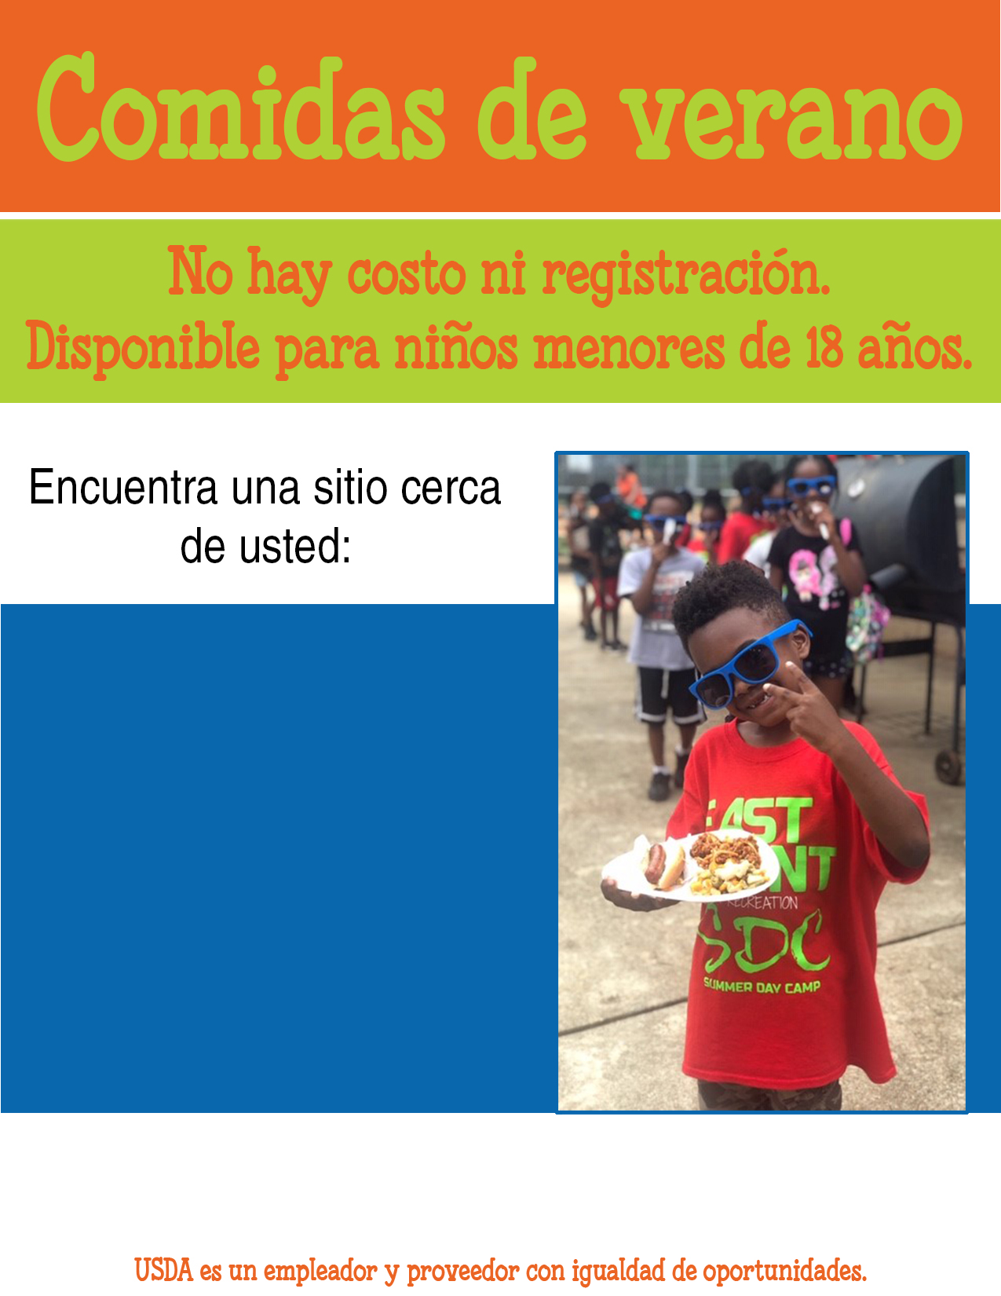

Esta institución es un proveedor que ofrece igualdad de oportunidades.

SPANISH TRANSLATION Contact information should go here   
along with additional information about your program if necessary

LOCATION NAME  
address  
days/hours

SPANISH Additional info like activities, crafts, books, etc.