Fresh Fruit and Vegetable Program (FFVP) Grant Accounting Codes

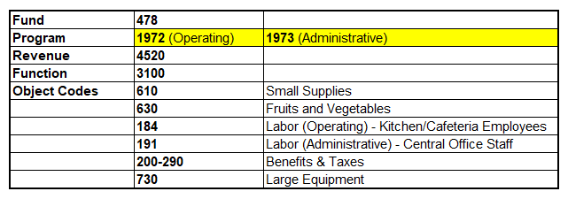

** Please do not use the old program code 1861, as it no longer applies to FFVP.

