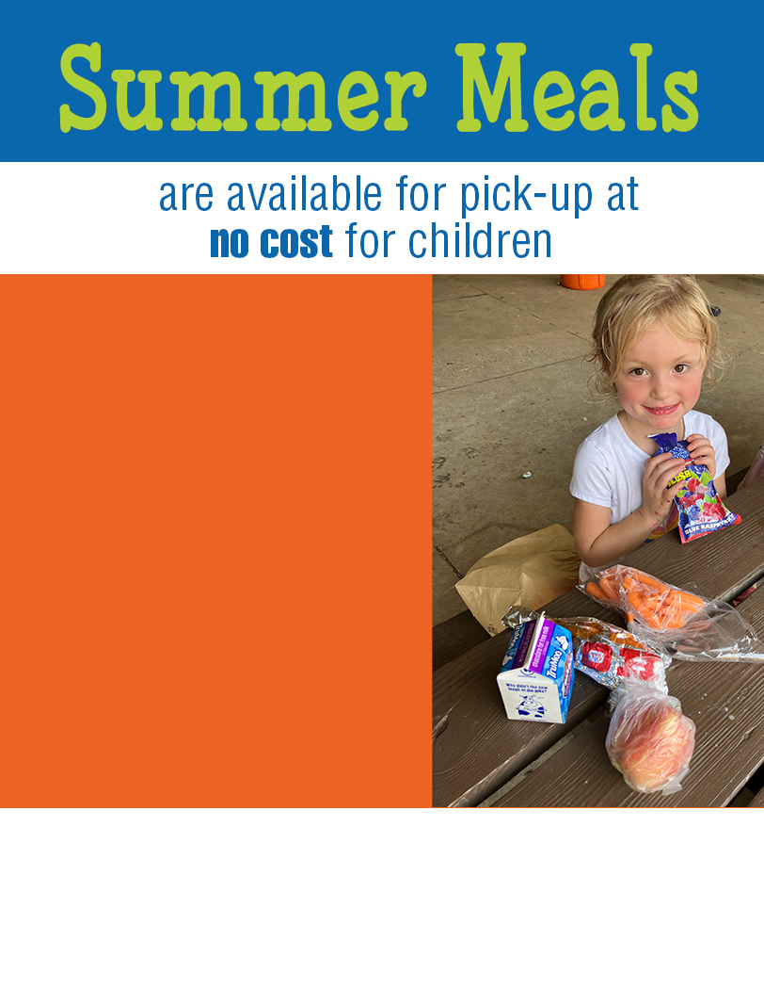

DATES   
meal time 1  
meal time 2

Limit one breakfast and one lunch per child  
per day.

Only a parent/guardian may pick up meals for children ages 18 and under.

This institution is an equal opportunity provider.

**Additional information about your program   
and contact information should go here.**