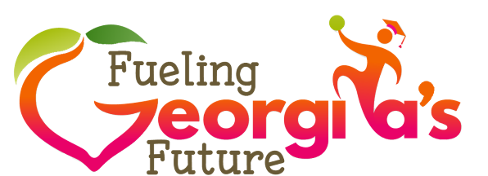
MAY 2019
USDA Regulations Regarding Sharing Food to Reduce Waste
The USDA encourages State agencies to support local education agencies (LEAs) in their efforts
to increase students’ consumption of nutritious foods and minimize food waste in their programs.
As such, USDA memo SP41, CACFP13, SFSP15-2016, “The Use of Share Tables in Child Nutrition Programs,” provides guidance for LEAs regarding options for managing food waste when students choose not to consume items they have selected. Assuming food and beverage items are pre-packaged and protected from intentional or unintentional contamination, the USDA allows food
and beverage items to be reused in the following ways, depending on the Program’s preference:
- Children may take an additional helping of a food or beverage item from the share table at
no cost;
- Food or beverage items left on the share table may be served and claimed for reimbursement during another meal service (i.e., during an afterschool program when leftover from a school lunch); and/or
- Food or beverage items may be donated to a non-profit organization, such as a community food bank, homeless shelter or other non-profit charitable organization.
While it is permissible to re-serve some food, a primary goal should be to decrease this need by increasing the likelihood that students will eat the food in the first place. For instance, Offer Versus Serve (OVS) helps reduce food waste by permitting students to decline foods they do not intend to eat. If you have not done so already, consider OVS as a means by which to reduce food waste by permitting students to decline foods they do not intend to eat.
Of course, even when every attempt is made to increase students’ consumption of healthy foods,
the problem of food waste continues. Fittingly, the USDA allows schools to create a “share table” or stations where students may return whole items they choose not to eat. However, the conditions must comply with State food safety regulations. To ensure “share tables” follow the Georgia Food Code, adherence to the recommendations in the Georgia Share Tables Standard Operating Procedure must be followed (Link to resource). Items left on a share table can either be offered for free to students desiring additional food or be served and claimed for reimbursement during another meal service.
If a School Nutrition Director decides to partner with a non-profit organization, there should be an explicit understanding and written agreement between the School Nutrition Program and the non-profit organization which clearly states that school nutrition employees are not responsible for the donated food. The School Nutrition Director should ensure that the partnering organization has written operational procedures in place and that they adhere to the food safety practices necessary to
“protect the health of children who receive the donated items. Because the agency accepting the food and beverage donations assumes the responsibility of the donated items, they must have a written Operational Plan that describes how the food and beverages will be protected from food
safety risk factors.

