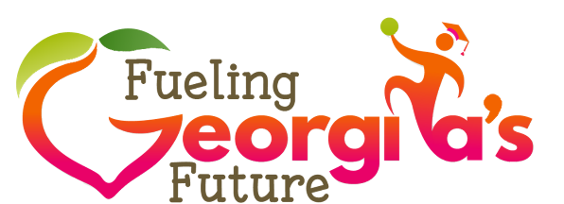
MAY 2019
Conversation Starters
Meal Charges / “Lunch Shaming”
Unpaid meal charges and “lunch shaming” are popular topics in the media. School officials may receive questions from the public and media regarding student charges and unpaid debt. Each system has a local meal charge policy which is required by USDA and can be a good resource.
HOW/WHY DOES THIS HAPPEN
- Sometimes, children who are not eligible for free or reduced-price meals enter the cafeteria without the funds needed to purchase a breakfast or lunch. This is a difficult situation for the child and our staff.
- The School Meal Programs must be financially self-sustaining. School lunch debt impacts our ability to serve all children high-quality, nutritious meals.
WHAT ARE WE DOING ABOUT IT
- We work to prevent unpaid meal charges by communicating with families via methods such as email, telephone calls, notes sent home, and/or in-person student reminders.
- School systems work to streamline payment options; many systems have online payment programs. These online programs often have free notification options which can alert families before an account reaches a negative balance.
- Each year, students receive a free or reduced-price meal application; many systems also have methods of applying online. School Nutrition staff work diligently to identify all families who may be able to take advantage of these confidential benefits.
- No one wants to cause a child distress during the school day, and we are continually
working to prevent “school lunch shaming” in our cafeteria(s).
- Our goal is to provide children with the well-balanced nutrition they need to be healthy and stay focused during the school day.

