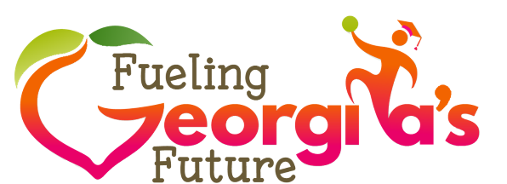
Serving School Garden Produce in School Meals
Best Practices for Food Safety
Obtaining produce from the school garden is a wonderful way to demonstrate support of your school and increase student participation in your program. Neither the Georgia Food Code nor USDA regulations prohibit using school garden produce in school meals. However, to help ensure the safety of school garden produce, the following best practice recommendations should be followed.
- Discuss planting and harvesting procedures with school garden coordinators.
Coordinators must be aware of food safety practices in the garden and display knowledge about Good Agricultural Practices and Good Handling Practices.
- Receive and inspect produce harvested from school gardens according to the same procedures used to inspect produce from other vendors.
- Reject produce that does not meet school nutrition program standards.
- Do not use any produce that has been noticeably contaminated by animals or insects.
- Refrigerate garden produce immediately, unless the item is normally held at
room temperature.
- Maintain traceability from the time you receive the produce until it is served.
If something should go wrong, traceability helps to determine causality.
  - Maintain a record of all produce received from school gardens that includes product/variety name, harvest date, and all persons involved in harvesting.
  - When practical, avoid mixing produce from different sources in storage, preparation, and service.
  - Document information on the menu production records to allow you to trace the menu item to the origin of the produce. Conduct a trace back and trace forward exercise to test how easily produce can be identified using the documentation on file.
- Although unlikely, it is possible that foodborne illness could be caused by school garden produce, especially because fruits and many vegetables are served raw. Thus, it may be wise to check with your district’s insurance department to ensure that produce from school gardens is covered in the event of a foodborne illness claim.

Resources for additional information

- USDA, Office of Community Food Systems. “School Gardens, Using Gardens to Grow Healthy Habits in Cafeterias, Classrooms, and Communities.” Available at: https://fns-prod.azureedge.net/sites/default/files/f2s/SchoolGardens.pdf Accessed May 6, 2019.
- eXtension Foundation. “Administrative Steps to Serving Garden Produce in the School Cafeteria.” Available at: https://articles.extension.org/pages/73402/administrative-steps-to-serving-garden-produce-in-the-school-cafeteria Accessed May 6, 2019.

