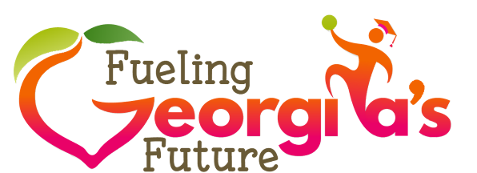
MAY 2019
Food Donation Liability Protection
Schools may be hesitant to donate surplus food to a nonprofit organization for fear of liability issues. Assuming absence of gross negligence, there are Federal and State laws that allow food to be donated without concern
of liability for unforeseen illness or injury related to the donated food.
The Bill Emerson Good Samaritan Food Donation Act (“Good Samaritan Act”) is a federal law aimed at “encouraging the donation of food and grocery products to nonprofit organizations for distribution to needy individuals” by providing a national standard of liability protection for both food donors and the nonprofits accepting these donations (1). In short, donors are protected from criminal and civil liability related to the donation of food unless there is gross negligence or intentional misconduct.
Georgia Code Ann. § 51-1-31 is a State law that also protects donors from criminal penalty or civil damages arising from the condition of the food, unless an injury is caused by the recklessness or intentional misconduct
of the donor (2). Therefore, a good faith donor (in this case, a school) is not liable for illness or injury caused by canned or perishable foods that are apparently fit for human consumption and have been donated to a nonprofit organization for use or distribution.
Lastly, the Consolidated and Further Continuing Appropriations Act, 2012 (P.L. 112-55) amended the Richard B. Russell National School Lunch Act (NSLA) by adding the Food Donation Program. The statute clarifies that any program food not consumed may be donated to eligible local food banks or charitable organizations. In this context, the terms “eligible local food banks or charitable organizations” means any food bank or charitable organization which is exempt from tax under section 501(c)(3) of the Internal Revenue Code (3).
Of course, even though food donors are legally protected from liability, strict food safety practices must be enforced, and due diligence executed before entering into an agreement with an organization that accepts
food donations.
References
- Cornell Law School, Legal Information Institute. 42 U.S. Code § 1791. Bill Emerson Good Samaritan Food Donation Act. Available at: https://www.law.cornell.edu/uscode/text/42/1791. Accessed May 10, 2019.
- Georgia General Assembly. O.C.G.A. § 51-1-31 Accessed May 10, 2019.USDA. Memo Code
SP 11-2012, CACFP 05-2012, SFSP 07-2012 Guidance on the Food Donation Program in Child
Nutrition Programs. Available at: https://www.usda.gov/oce/foodwaste/FNS_Guidance.pdf. Accessed May 10, 2019.
Additional Resources
- Center for Agriculture and Food Systems. National Gleaning Project. Legal and Policy Resources. Available at: https://nationalgleaningproject.org/ Accessed May 10, 2019.
- Food Law and Policy Clinic, Harvard Law School. Food Safety Regulations & Guidance for Food Donations: A Fifty-State Survey of State Practices March 2018. Available at: https://www.chlpi.org/wp-content/uploads/2013/12/50-State-Food-Regs_March-2018_V2.pdf Accessed May 10, 2019

