<< ENTER SCHOOL OR DISTRICT NAME
AND/OR LOGO HERE >>
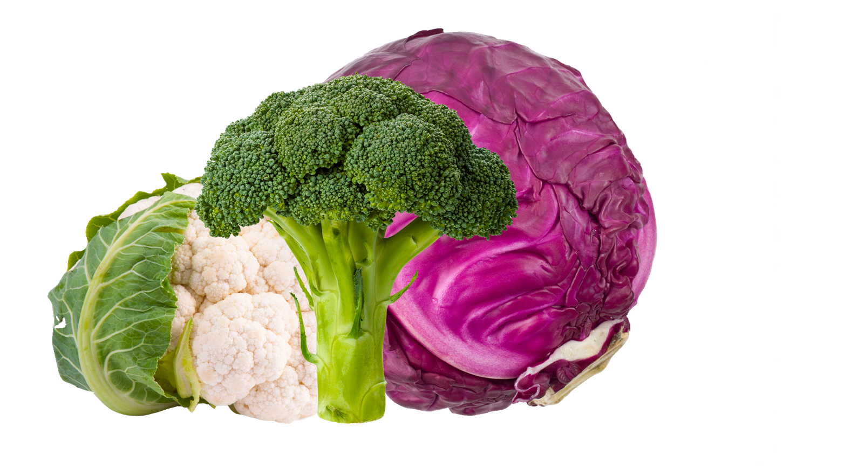
is proud to serve locally grown
cruciferous vegetables in February

