Flier for Households   
Submit Verification Documents with Your Smartphone!

How to use this resource

This document contains a customizable English/Spanish flier that School Food Authorities (SFAs) can send to households to advertise the option to submit verification documents by taking pictures of them and emailing the photos to the SFA office.

Before sending this flier out to families, be sure to customize it with your district’s email address, submission deadline, address, phone number and other relevant information.

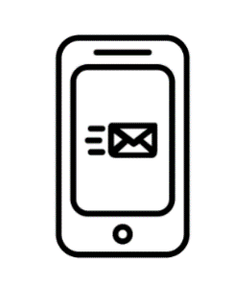

**An "i" with a circle around it - an icon representing "information."**

**Submit** your **verification documents** without a trip to the post office or school! Use the **camera** on your **phone** or tablet to take pictures of them and   
**e-mail** the pictures   
and your child’s name to **[email@schooldistrict.edu]**

Be sure to submit your information by:   
**[Month] [xx], 20[xx]**

You may also submit your information by mail or return it in person at your child’s school. If you decide to send your documents by mail, please send them to: << address>>.

If you have questions about the verification process or the types of documents you need to send, contact student eligibility and accountability at <<phone number>>.



**An "i" with a circle around it - an icon representing "information."**

**Presente** sus **documentos de verificación** sin necesidad de acercarse a la escuela o a la oficina de correos! Utilice la **cámara** de su **teléfono** o tableta para tomar fotografías de estos documentos y envíe las fotografías y el nombre de su hijo/a por **correo electrónico** a **[email@schooldistrict.edu]**

Asegúrese de presentar la información antes del:   
**[xx] de [mes] de 20[xx]**

También puede enviar su información por correo o presentarla en persona en la escuela de su hijo/a. Si decide enviar sus documentos por correo, envíelos a: <<address>>.

Si tiene alguna pregunta con respecto al proceso de verificación o los tipos de documentos que debe enviar, comuníquese con Elegibilidad de Estudiantes y Contabilidad al <<phone number>>.