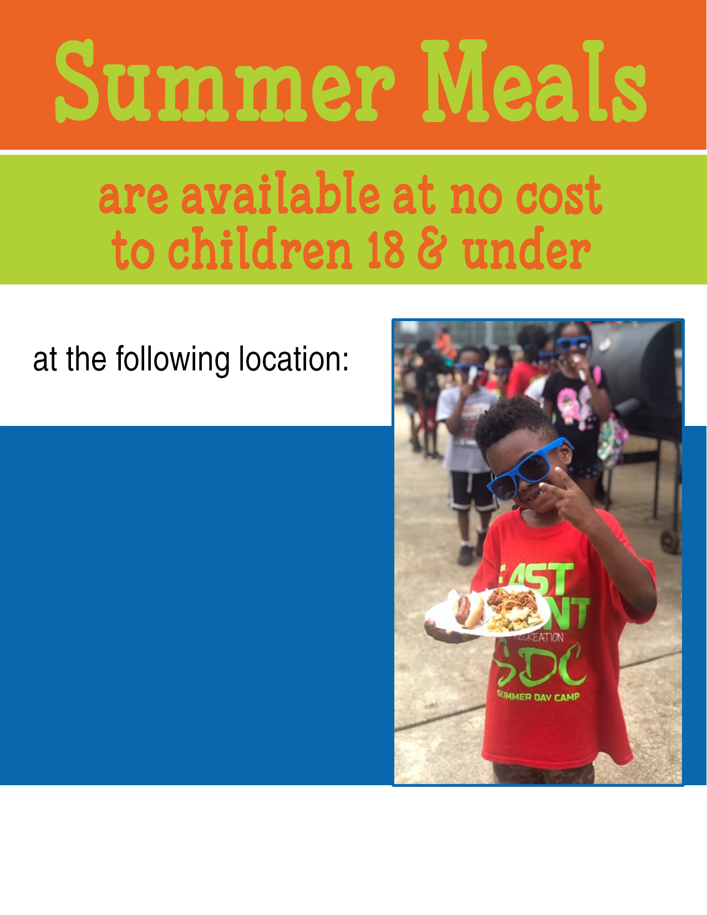

This institution is an equal opportunity provider.

Contact information should go here along with   
additional information about your program if necessary

LOCATION NAME  
address  
days/hours

Additional info like activities, crafts, books, etc.