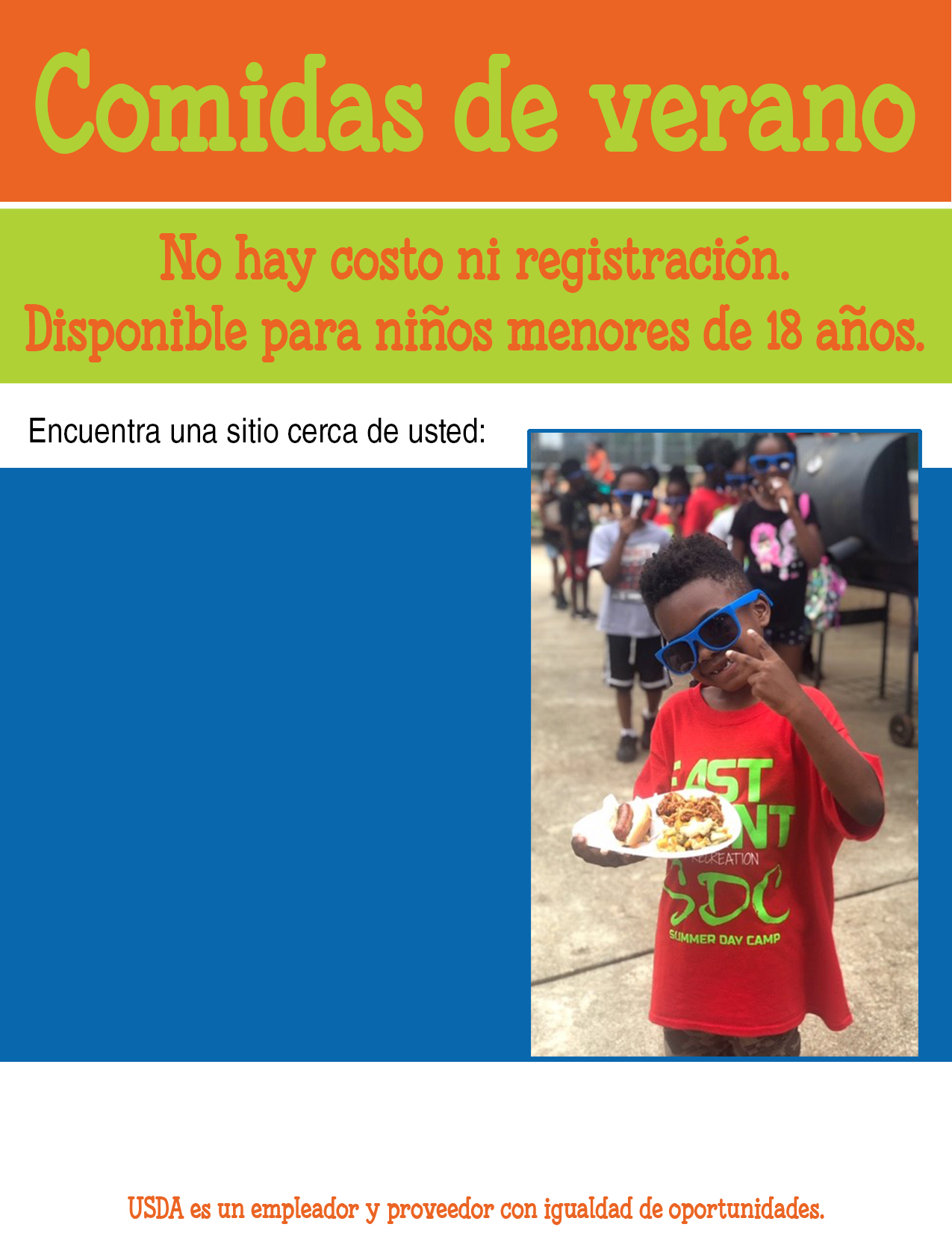

IN SPANISH Additional information about your program   
and contact information should go here.

LOCATION NAME  
address  
days/hours

LOCATION NAME  
address  
days/hours

LOCATION NAME  
address  
days/hours

LOCATION NAME  
address  
days/hours