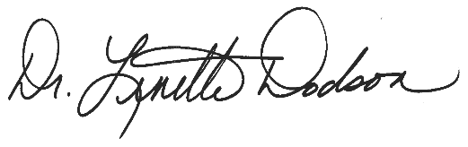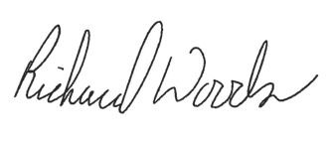

in recognition of successful completion of

consisting of **1.5** credit hours of instruction  
for School Nutrition Personnel

Professional Standards Learning Code: **4120**

**MC2021 *Virtual Be Excellent!*   
*Marketing and Promoting Your Program***

Date of Training

State School Superintendent

Director, School Nutrition Program

3/23/2021

***(Enter Your Name Here)***

Error! Bookmark not defined.

awards this certificate to