Food Distribution - SFA
Task Guide

Table of Contents
Table of Contents 1
1 Introduction 3
2 Document Conventions 3
3 District—Food Distribution Home Page 4
4 District—Configuration 5
4.1 USDA Foods List 5
4.2 Processors 8
5 District—Catalogs 12
5.1 Catalogs 12
5.1.1 Direct Ship Catalog Response 12
5.1.2 Processed Goods Catalog Response 14
6 District—Orders/Receipts 20
6.1 Receipts 20
6.2 Bill of Lading List 23
7 District—Transfers 24
7.1 Transfer USDA Foods 24
7.1.1 Create RA to RA Transfer 24
7.2 Transfers List 26
7.2.1 Acknowledge RA to RA Transfer 26
7.3 Advertisements List 29
7.3.1 Respond to Advertisement 29
7.3.2 Acknowledge Advertisement 30
8 District—Recalls/Complaints 32
8.1 Recall List 32
8.2 Complaint List 35
9 District—Reports 38
9.1 Orders 38
9.2 PAL Balances 39
9.3 USDA Item History 40
9.4 Catalog Response 41
9.5 Commodity Perpetual Inventory 42
9.6 Transaction History 43
9.7 Shippers Breakdown 44
10 District—Management 45
10.1 Planned Assistance Level 45
10.2 Commodity Drawdown 46
10.3 Forms 48

Disclaimer
Every effort has been made to make this manual as complete and as accurate as possible, but no warranty or fitness is implied. The information provided is on an as is basis. Changes made to the product may not be reflected in this manual. Cybersoft Technologies shall have neither liability nor responsibility for any loss or damages arising from the use of information contained in this manual.

Food Distribution - SFA
Task Guide

Introduction
PrimeroEdge Software structure contains Realms, Modules, Categories and Functional Areas. The hierarchy allows for easy navigation and division between tasks. The structure provides for comprehensive operations while remaining easy to navigate.

Document Conventions
This document uses the following typographical conventions:
- Bold Print: this print represents Modules, Categories, Functional Areas and key names such as Tab or Enter keys.
- Italics: this print represents messages such as User has been added successfully. This print represents variable information such as information you type on command lines.
- Buttons: Bold print and/or a graphic image of a button represents button names such as Apply.
Selection Sequences: The names of each PrimeroEdge Module, Category and Functional Area act as a tool for navigation when placed between arrows. Arrows represent selection sequences in order from left to right as in Module > Category > Functional Area. An example of a sequence is Inventory > Orders > Create Orders.

Modules, Categories and Functional Areas will be available to you based on your Role Permissions.
Icons in this document alert the reader to special information.
- The green check box represents helpful tip.
- The red triangle represents a warning with critical task information.
- The blue circle represents a status note.

District—Food Distribution Home Page
Click the Food Distribution Module tab. The Food Distribution Home page provides a snapshot of your organization’s Food Distribution performance in the District Realm.
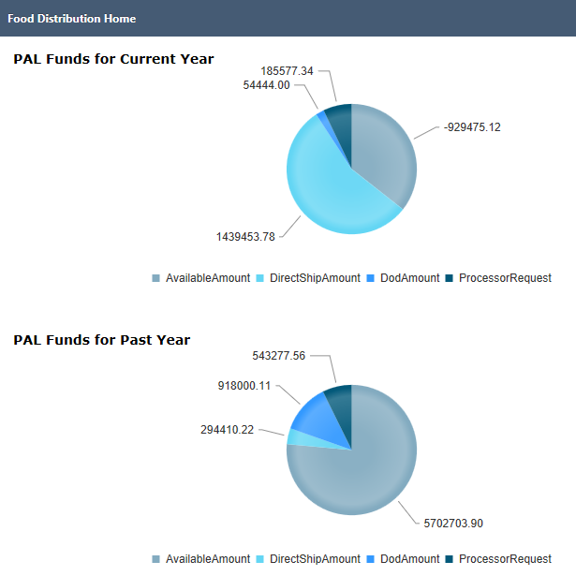
Figure 1 Food Distribution Home Page--District Realm

District—Configuration
This Category contains tasks for managing configuration in the District Realm. Improper configuration settings may result in inaccessible functions.

USDA Foods List
This section contains tasks for managing the USDA Foods List.
Go to District > Food Distribution > Configuration > USDA Foods List
You cannot edit the USDA Foods List in the District Realm.
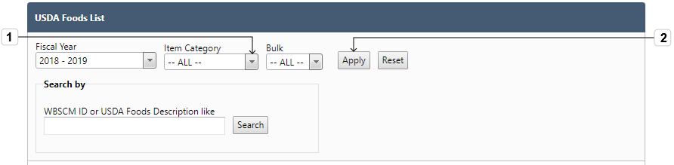
Figure 2 USDA Foods List Filters
- Select the Item Category and Bulk
- Click Apply
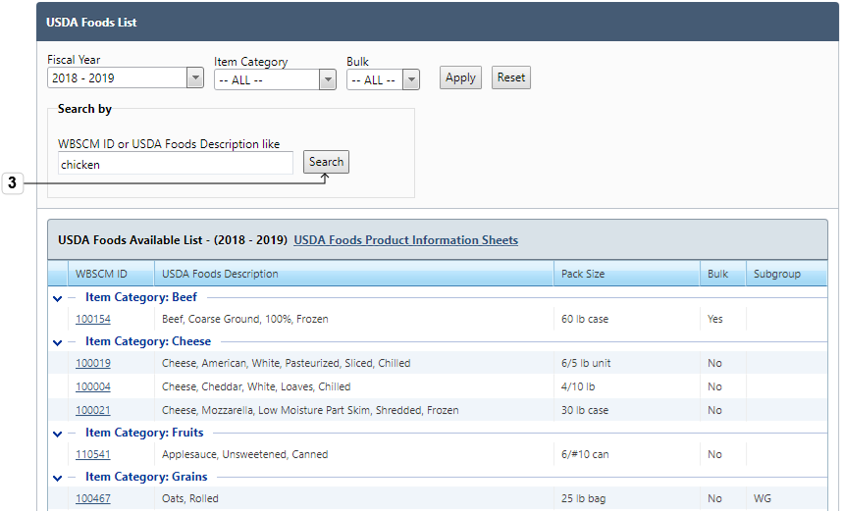
Figure 3 USDA Foods List

- Search by entering part of the Item Number or Description in the WBSCM ID or USDA Foods Description like text field and click Search
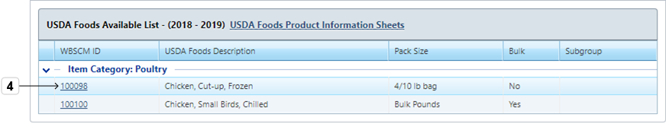
Figure 4 USDA Foods Available List - (2018-2019)
- Click the hyperlink under WBSCM ID column header
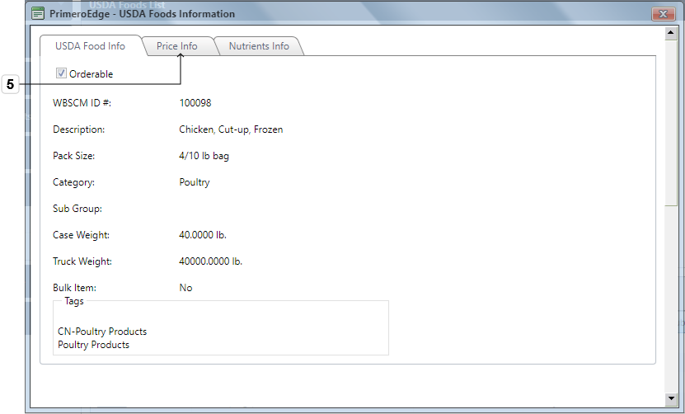
Figure 5 USDA Foods Info
- Click the Price Info tab to view the item's pricing information
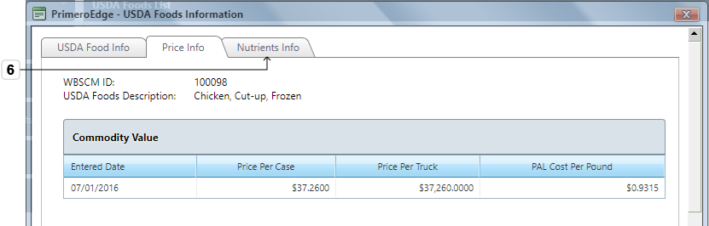
Figure 6 USDA Foods Price Info
- Click the Nutrients tab to view the item’s nutritional information
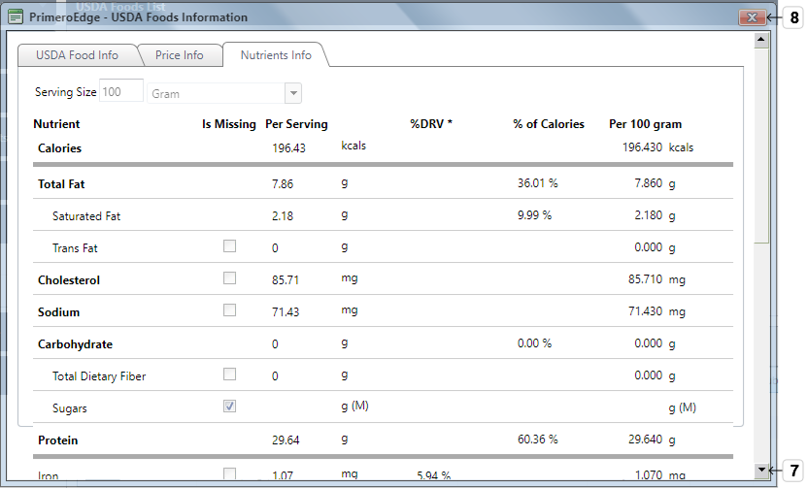
Figure 7 USDA Nutrients Info Tab
- Scroll or resize view to see all the nutritional information
- Click Close to exit the view

Processors
SFA/Sponsors or contracting entity (CE) often use the food processing industry to convert bulk or hard-to-use USDA foods into more convenient and usable products.
Federal law requires that CEs receive the full value of their USDA Foods. When processing, this value must pass through to the CE by the processor. The Value Pass-through Method is the term for crediting the CE for the value of the USDA Food.
Go to District > Food Distribution > Configuration > Processors
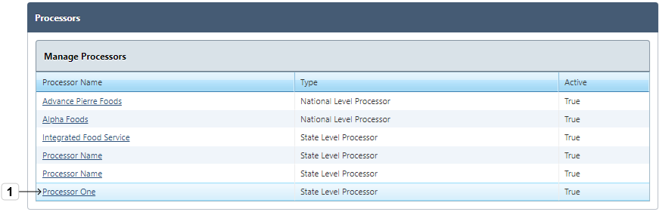
Figure 8 Manage Processors
- Click the hyperlink under the Processor Name column header
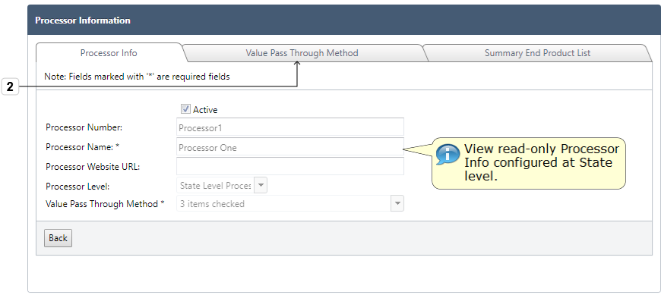
Figure 9 Processor Info
- Click the Value Pass Through Method tab
This is a read-only view. Processor Configuration occurs in the Central Realm.
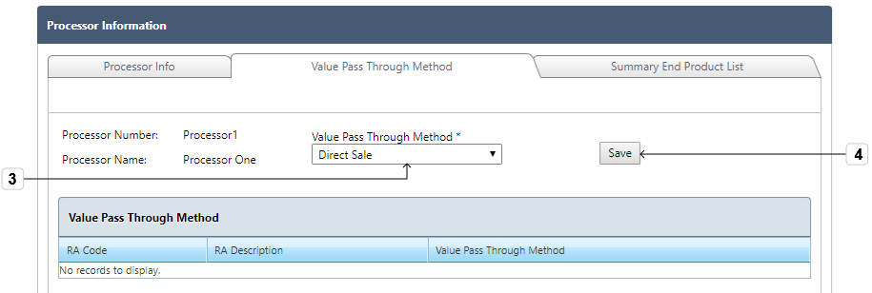
Figure 10 Value Pass-through Method
- Use dropdown menu to select Value Pass Through Method for the Recipient Agency
The options in Step 3 are set in the Central Realm.
- Click Save
View the Green success note and the change listed under the Value Pass-through Method section header.
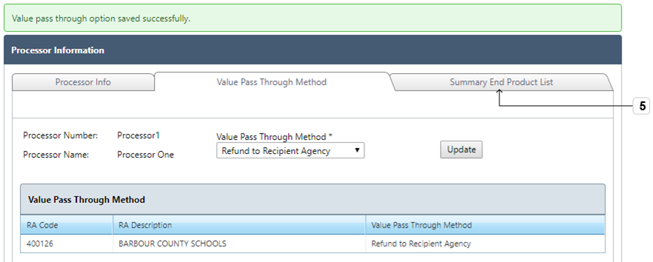
Figure 11 Value-pass Through Method Selection
- Click Summary End Product List tab to view SEPDS (Summary End Product Data Schedule) information
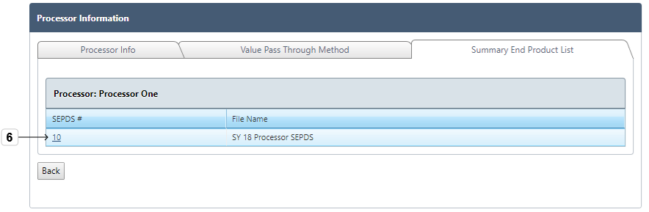
Figure 12 Summary End Product List
- Click the hyperlink under the SEPDS# column header to open and view individual SEPDS file
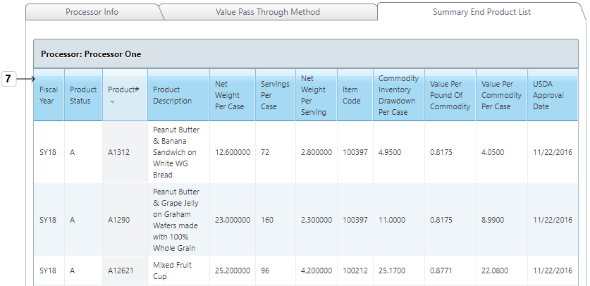
Figure 13 Processor: Processor One List
- View SEPDS items and click column headers to change the list order
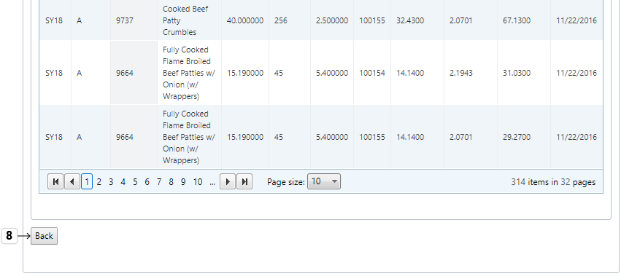
Figure 14 Back Button
- Click Back to return to SEPDS list or other tabs

District—Catalogs
This Category contains tasks for managing Direct Ship Catalog Response and Processed Goods Catalog Response in the District Realm.

Catalogs
This section contains tasks for responding to open Catalogs.
Go to District > Food Distribution > Catalogs > Catalogs

Direct Ship Catalog Response
This page allows districts to respond to an open catalog with requested quantities of items.
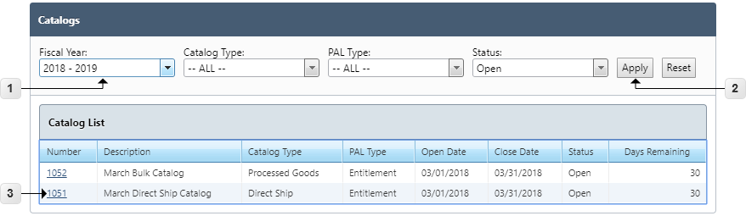
Figure 15 Catalogs
- Select the Fiscal Year, Catalog Type, PAL Type and Status
- Click Apply or Reset apply or reset the selections
- Click the hyperlink under the Number column header to open the catalog
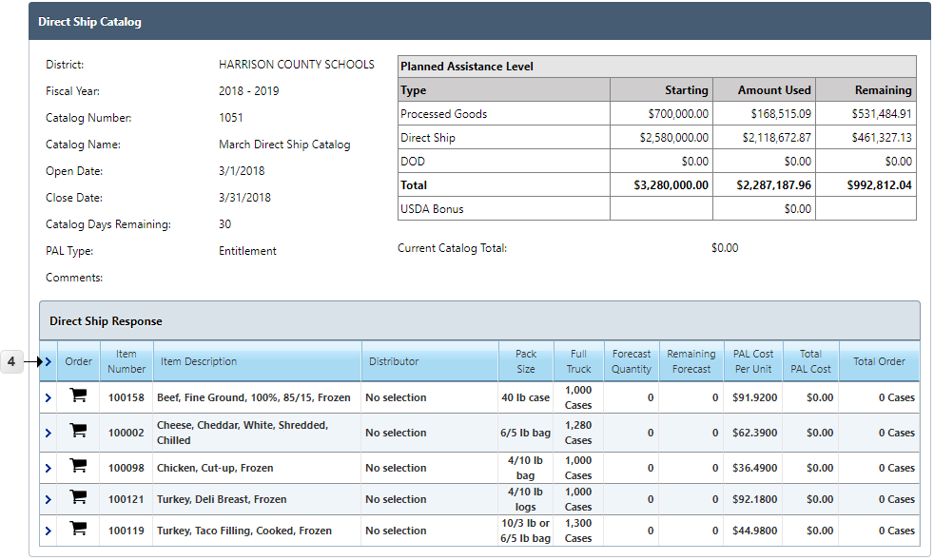
Figure 16 Direct Ship Catalog
- Click Expand arrow for the header or a single item to expand Order Calendar sub-grid
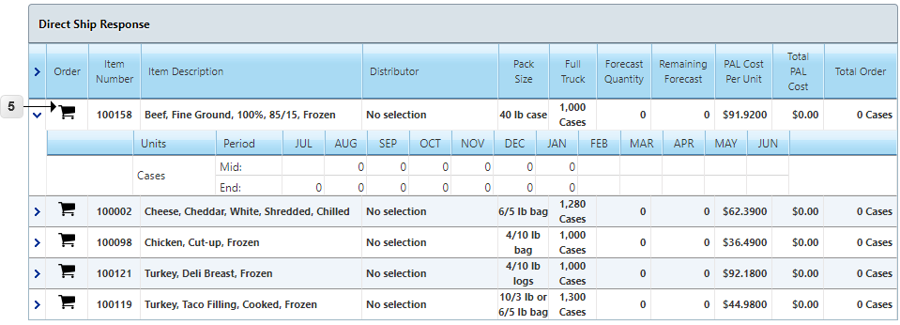
Figure 17 Direct Ship Response
- Click Cart to enter order quantities for the selected item
The Delivery Periods with a numerical value are the possible delivery dates. The dates with an empty cell indicate that the item is not orderable for that date.
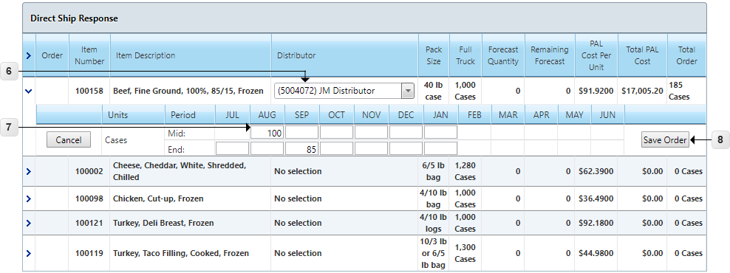
Figure 18 Direct Ship Order
- Select the Distributor
- Enter Order Quantities
- Click Save Order (Cancel to cancel order entry)
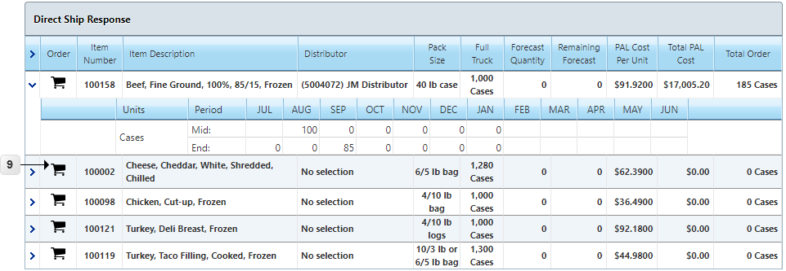
Figure 19 Direct Ship Order
- Click Cart to enter orders for other items and repeat until catalog response is complete

Processed Goods Catalog Response
This page allows districts to respond to an open catalog with requested quantities of bulk items and associated processor end products.
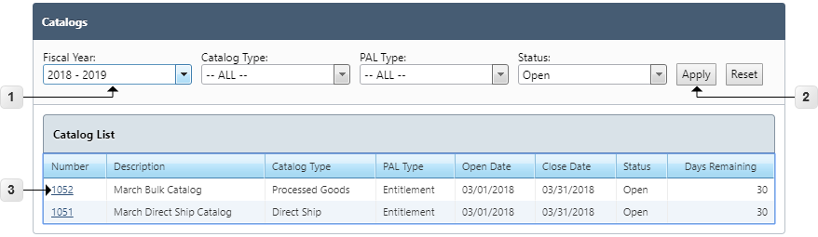
Figure 20 Catalogs
- Select the Fiscal Year, Catalog Type, PAL Type and Status
- Click Apply or Reset to apply or reset the selections
- Click the hyperlink under the Number column header to open the catalog
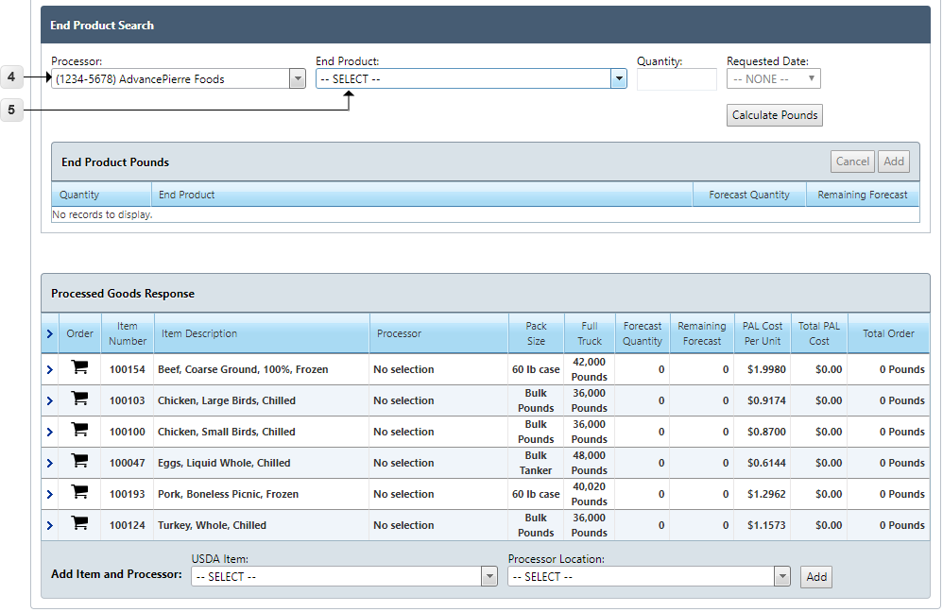
Figure 21 End Product Search
- Select the Processor to order pounds through End Products
- Select an End Product
Ordering through End Products is an optional feature. Ordering pounds directly is shown in Step 20.
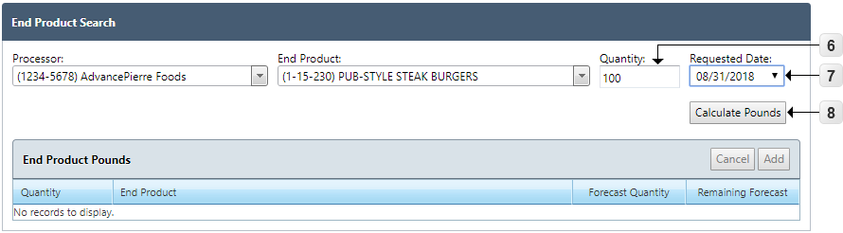
Figure 22 Calculate Pounds
- Enter End Product Quantity
- Select Requested Date
- Click Calculate Pounds
The system calculates Commodity Pounds based on the End Product quantity request.
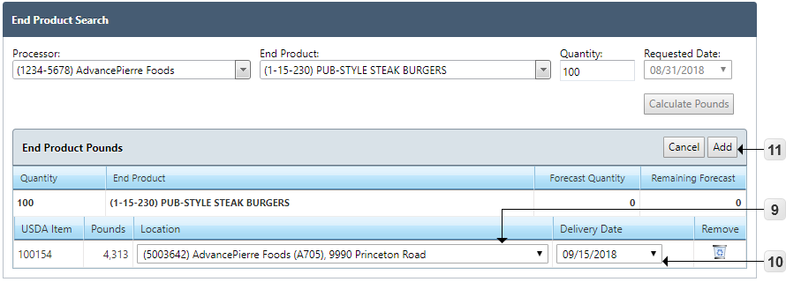
Figure 23 End Product Pounds
- Select the Processor Location for the USDA Item
- Select a Delivery Date
- Click Add (Cancel to cancel and add a different End Product)
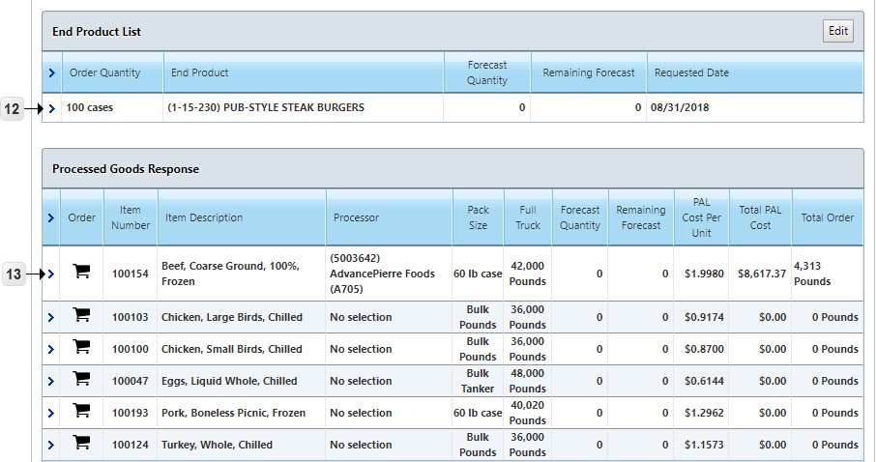
Figure 24 Processor End Products
The End Product record is created in the End Product List and the corresponding Pounds are inserted in the Processed Goods Response grid.
- Click Expand > arrow to display End Product details
- Click Expand > arrow to display Commodity Pounds details
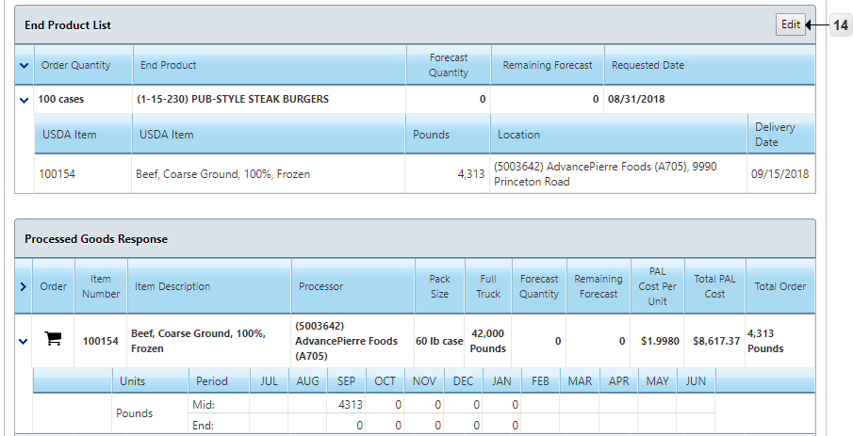
Figure 25 End Product List
- Click Edit to modify End Product Quantity
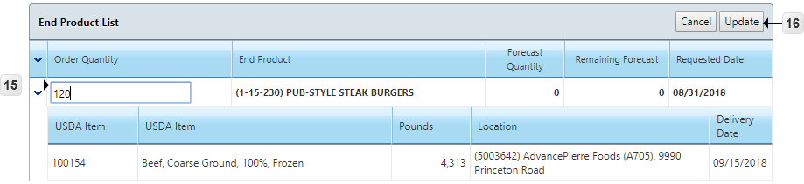
Figure 26 Update End Product Quantity
- Modify End Product Order Quantity
- Click Update (Cancel to revert any changes)
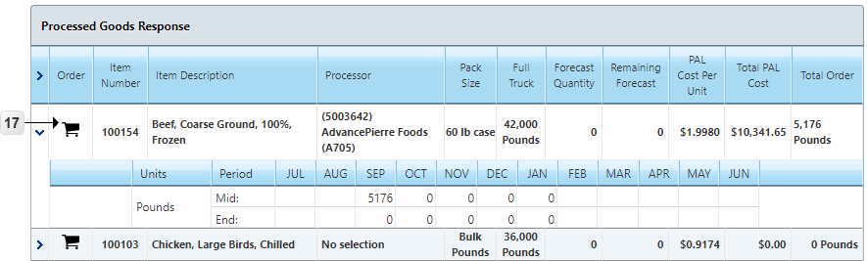
Figure 27 Processed Goods Response
- Click Cart to enter order quantities for the selected item
The Delivery Periods with a numerical value are the possible delivery dates. The dates with an empty cell indicate that the item is not orderable for that date.
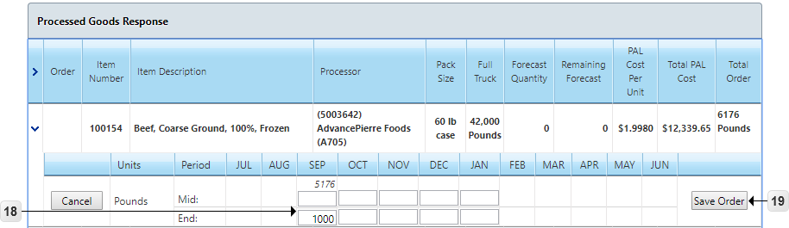
Figure 28 Processed Goods Order
- Enter Order Quantities
The italicized quantities above the order fields are the calculated pounds from End Products and are not editable through this grid. The End Product Pounds are modified through the End Product List. Processor is also not editable as it has been selected through the End Product tool.
- Click Save Order (Cancel button to cancel order entry)
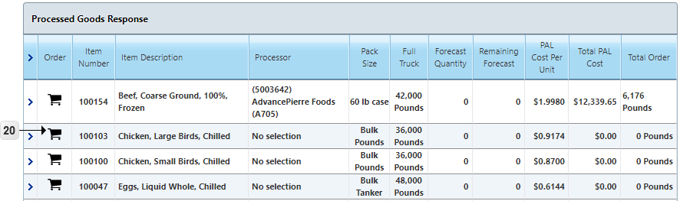
Figure 29 Processed Goods Response
- Click Cart to enter manual (non End Product derived) order quantities for another item
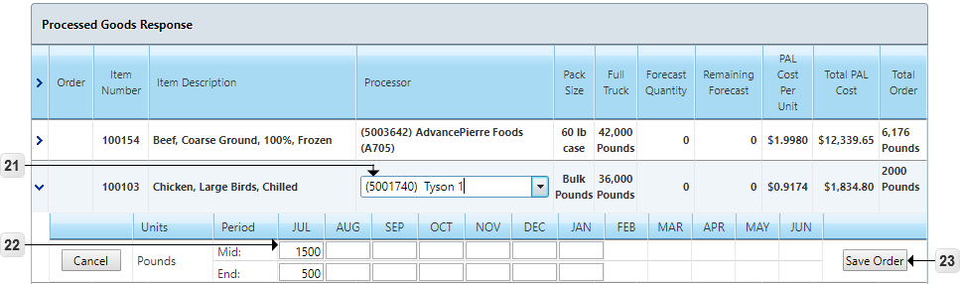
Figure 30 Processed Goods Manual Entry
- Select the Processor Location
- Enter Order Quantities
- Click Save Order
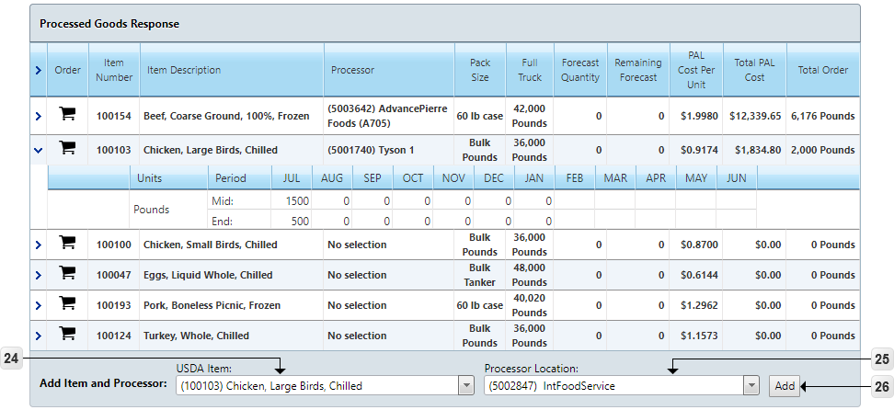
Figure 31 Add Item and Processor
- Select USDA Item in the Add Item Processor tool to add an Item already on the catalog but with a different Processor.
- Select Processor Location
- Click Add
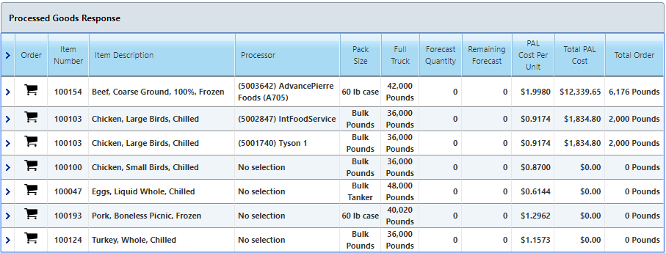
Figure 32 Processed Goods Catalog Response
Repeat the process, ordering through either End Product tool or Manual Entry, until all desired items have saved order quantities.

District—Orders/Receipts
This Category contains tasks for managing Orders/Receipts in the District Realm. These tasks include Receipts and Adding a Complaint.

Receipts
This section contains tasks for managing Receipts. The Receipts page lists all receipts for a fiscal year and allows for the editing of certain receipt information.
Go to District > Food Distribution > Orders/Receipts > Receipts
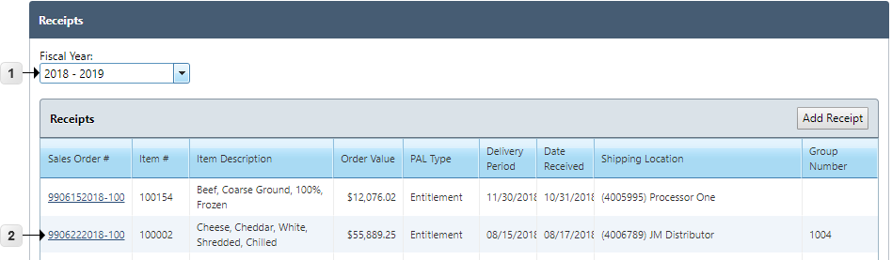
Figure 33 Receipts
- Select the Fiscal Year
- Click the Sales Order # link to open and view a Receipt
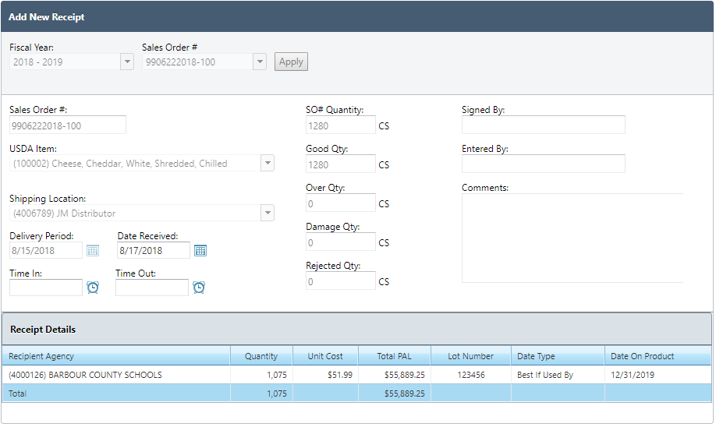
Figure 34 View Receipt
- View the read-only Receipt information created at the State level
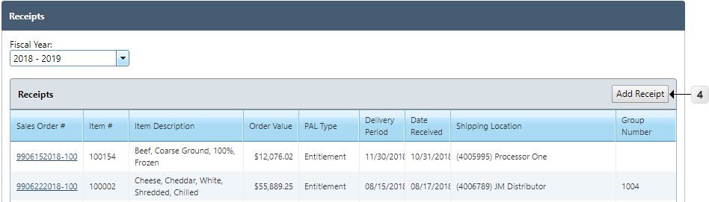
Figure 35 Add Receipt Button
- Click Add Receipt to add a new receipt
Note: District-level Add Receipt functionality is only available to District Warehouse users with the appropriate permissions.
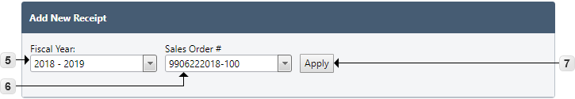
Figure 36 Add Receipt
- Select the Fiscal Year for the new Receipt
- Select the Sales Order Number
- Click Apply
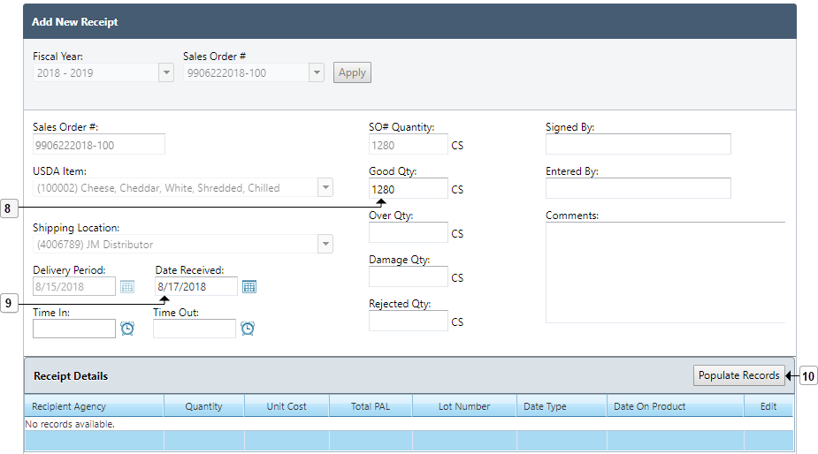
Figure 37 Add Receipt
- Enter Receipt Good Quantity
- Enter Date Received
All other fields are optional
- Click Populate Records to create the individual receipt records
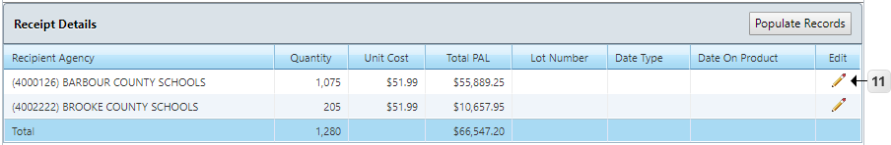
Figure 38 Receipt Details
- Click the Edit Pencil to add lot information
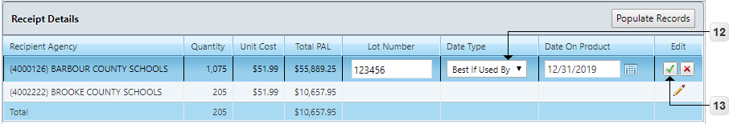
Figure 39 Edit Receipt Details
- Enter the Lot Number, Date Type, or Date on Product
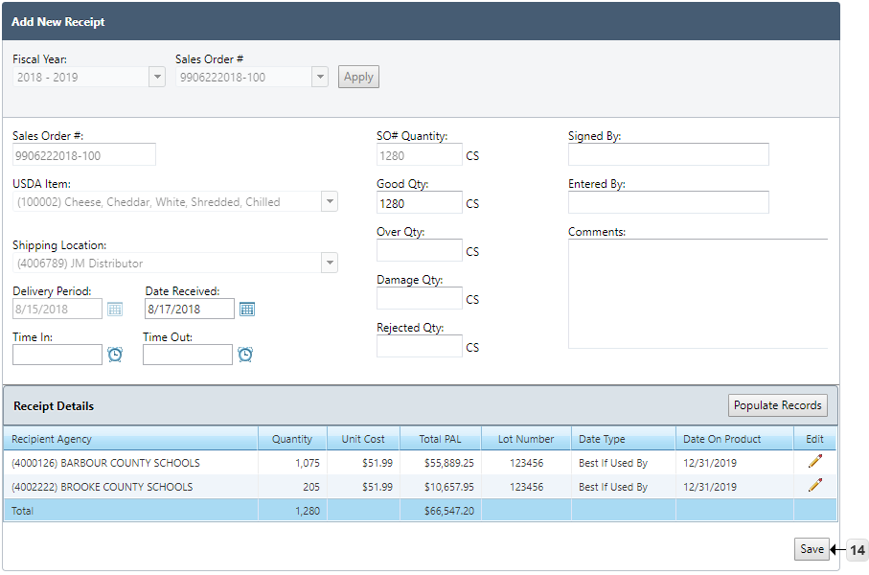
- Click the checkmark icon to confirm changes
Figure 40 Save Receipt
- Click Save to confirm the Receipt

Bill of Lading List
This Functional Area contains tasks for managing a Bill of Lading List.
You must first import a spreadsheet (.xml) of data from WBSCM for this Function to work.
Go to District > Food Distribution > Orders/Receipts > Bill of Lading List
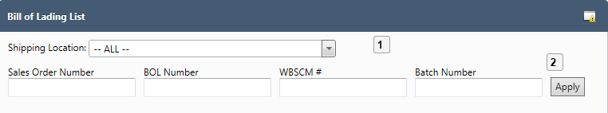
Figure 41 Bill of Lading List Selections
- Select the Shipping Location and enter text for Sales Order Number, BOL Number WBSCM# and Batch Number
- Click Apply
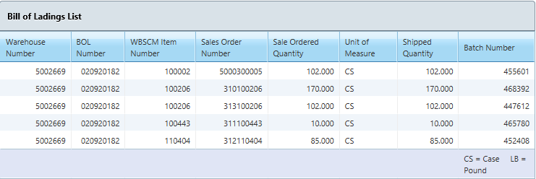
Figure 42 Bill of Ladings List
The Bill of Ladings List displays.

District—Transfers
Manage transfers in the District Realm using the PrimeroEdge tools for the Transfer of USDA Foods, Transfers List and Advertisements List. Transfers occur from one Recipient Agency (RA) to another RA.

Transfer USDA Foods
This section contains steps for creating a transfer from one RA to another RA. Additionally, this section contains the steps for acknowledging the RA to RA Transfer.
Go to District > Food Distribution > Transfers > Transfer USDA Foods

Create RA to RA Transfer
This section contains the steps in creating the RA-to-RA Transfer.
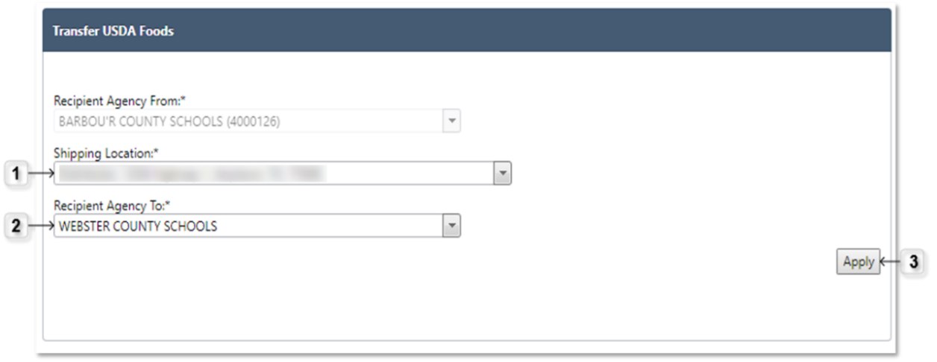
Figure 43 Transfer USDA Foods
- Select the Shipping Location
- Select the Recipient Agency to receive the transfer
- Click Apply
Figure 44 Field for Optional Comments
- Use the text-entry field to enter optional Comments
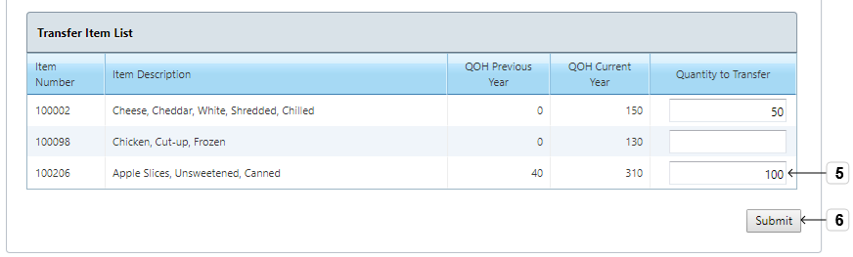
Figure 45 Transfer Item List
- Enter Quantity to Transfer for at least one item
- Click Submit
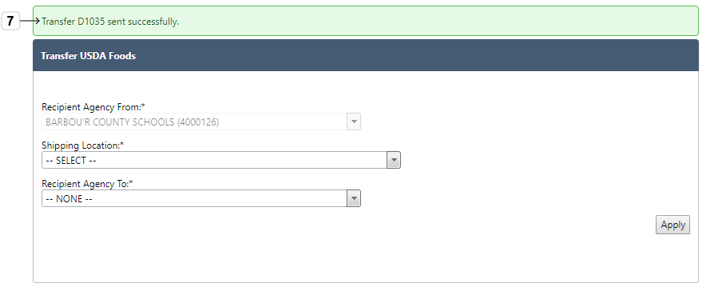
Figure 46 Transfer Success Note
- Review Green Transfer success note indicating the Transfer submittal, Transfer assignment number and appearance on the Transfers List

Transfers List
This section contains tasks for taking actions through the Transfers List.
Go to District > Food Distribution > Transfers > Transfers List

Acknowledge RA to RA Transfer
This section contains tasks for the District Realm to acknowledge the Central Realm.
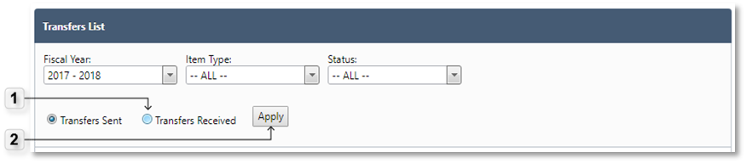
Figure 47 Transfers Received
- Select Transfers Received
- Click Apply
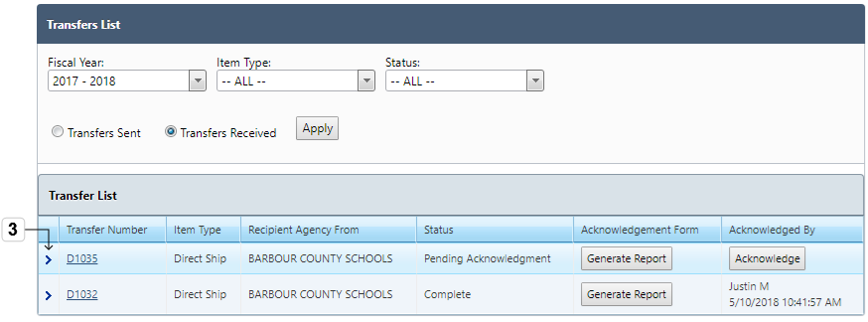
Figure 48 Transfer List
- Click Expand Arrow > to view Transfer item details and Collapse Arrow (v) to close the detail view
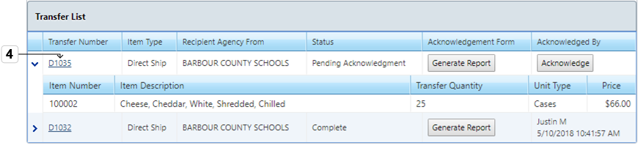
Figure 49 Transfer Number Hyperlink
- Click the Transfer Number hyperlink to open the RA to RA Transfer
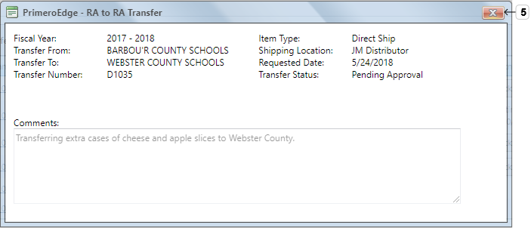
Figure 50 RA-to-RA Transfer
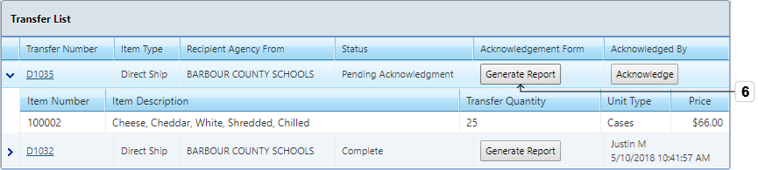
- Click X to close the box
Figure 51 Generate Report Button
- Click Generate Report under the Acknowledgement Form column header on the Transfer List

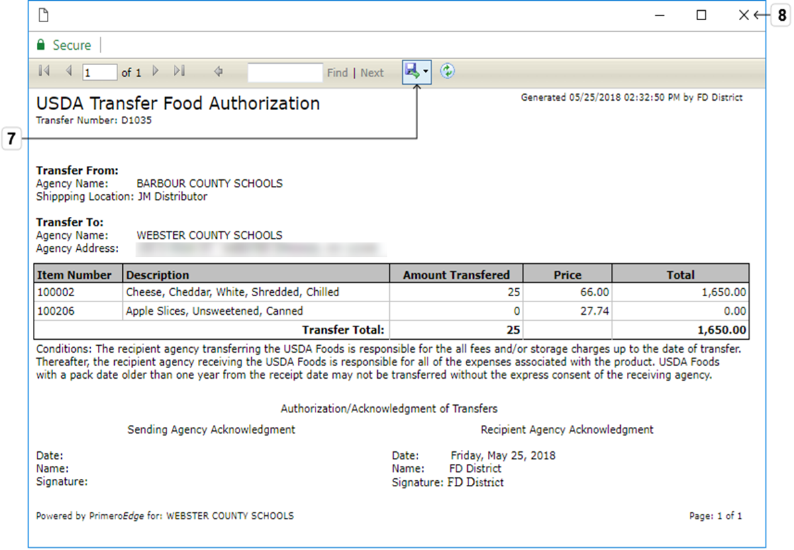
Figure 52 USDA Transfer Food Authorization Report
- Click the Export icon to export the form in various formats
- Click the X to exit the report viewer
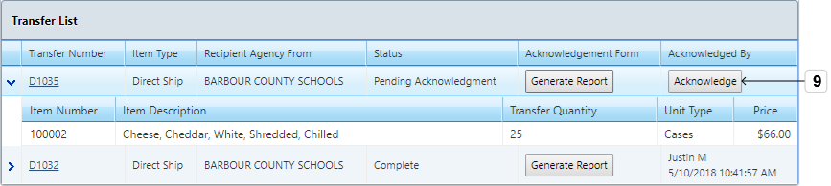
Figure 53 Acknowledge Button
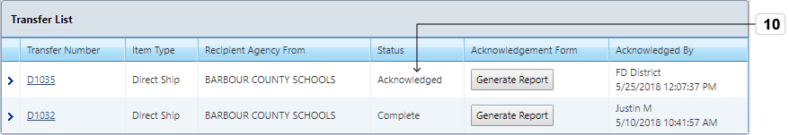
- Click Acknowledge under the Acknowledged By column header
Figure 54 Transfer List
View the Transfer Status Acknowledgement under the Status column header
The Transfer is now available for completion in the Central Realm.

Advertisements List
In the first part of the Advertisement process, the Central Realm posts the Advertisement. The District Realm then responds. The Central Realm then completes and generates the acknowledgement. In the last part of the process, the District Realm acknowledges the Central Realm.
Go to District > Food Distribution > Transfers > Advertisements List

Respond to Advertisement
This section contains tasks for the District to respond to an open Advertisement. This allows the district to respond with requested quantities of USDA foods on an advertisement posted by the state.
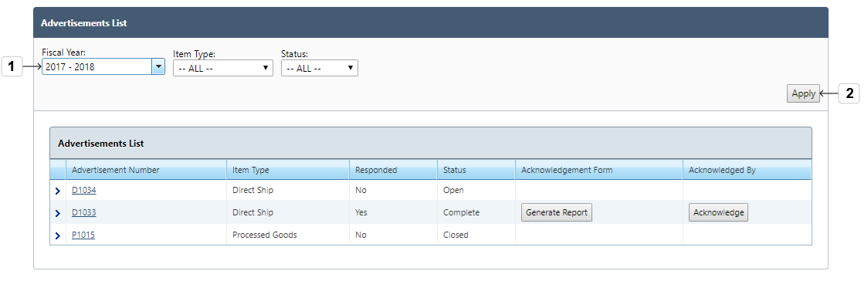
Figure 55 Advertisement List
- Select the Fiscal Year, Item Type and Status
- Click Apply
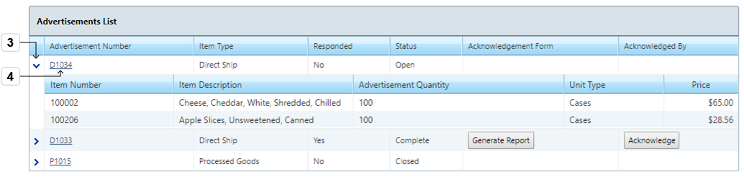
Figure 56 Hyperlink and Expansion Arrows
- Click Expand Arrow > to view the item details of the Advertisement and the Collapse Arrow (v) to close the detail view
- Click the Advertisement Number hyperlink of an Advertisement in Open status to open the Advertisement Response page
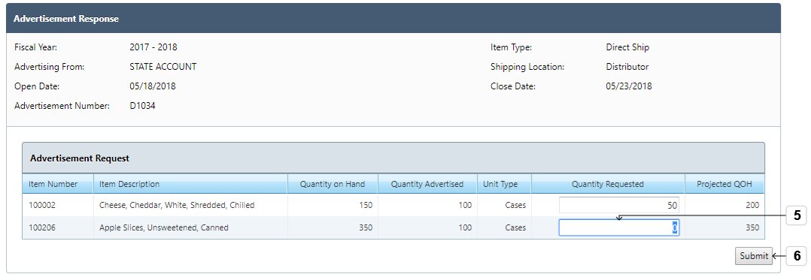
Figure 57 Advertisement Response
- Enter Quantity Requested for Advertisement item(s)
- Click Submit

Acknowledge Advertisement
This section contains tasks for acknowledging an advertisement in the District Realm. After an Advertisement is completed at State level and acknowledgment is requested, the RA can acknowledge at the Advertisements List.
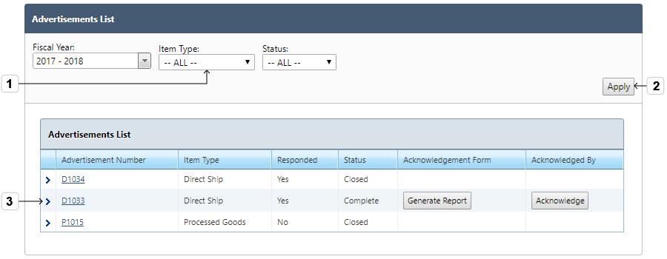
Figure 58 Advertisements List
- Select the Fiscal Year, Item Type and Status
- Click Apply
- Click Expand Arrow > to view the item details of the Advertisement and the Collapse Arrow (v) to close the detail view
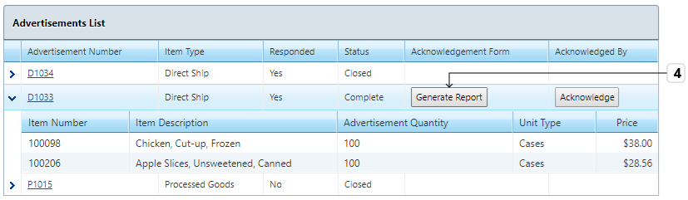
Figure 59 Generate Report Button
- Click Generate Report to view the Advertisement Acknowledgement form
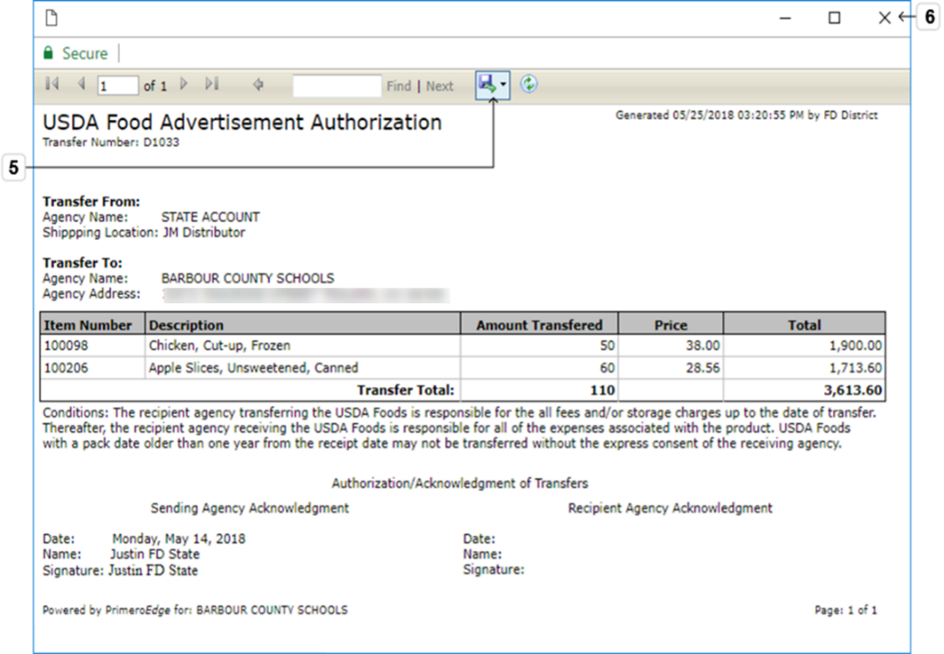
Figure 60 USDA Food Advertisement Authorization (Acknowledgement)
- Click the Export icon to export the form in various formats
- Click the X to close the report view
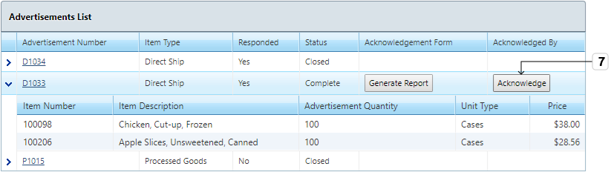
Figure 61 Acknowledge Button
- Click Acknowledge under the Acknowledged By column header
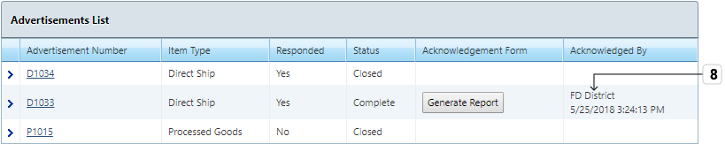
Figure 62 Advertisements List
- Advertisement is Acknowledged to the Central Realm

District—Recalls/Complaints
This Category provides a method to capture and log recalls into the system.

Recall List
This section contains tasks for managing the Recall List.
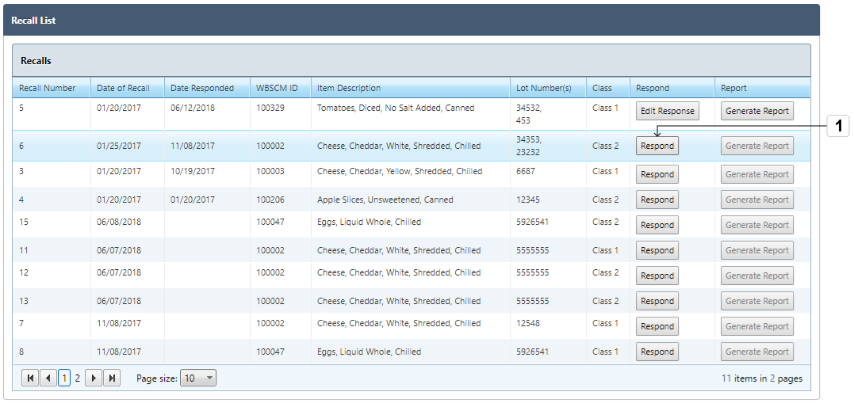
Go to District > Food Distribution > Recalls/Complaints > Recall List
Figure 63 Recalls
- Click Respond to respond to a recall
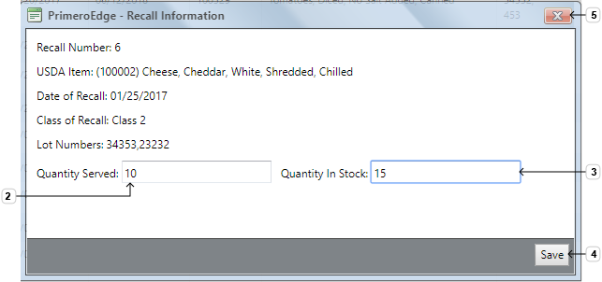
Figure 64 Recall Information
- Enter Quantity Served
- Enter Quantity in Stock
- Click Save
- Click X to close the view
Edit a Recall
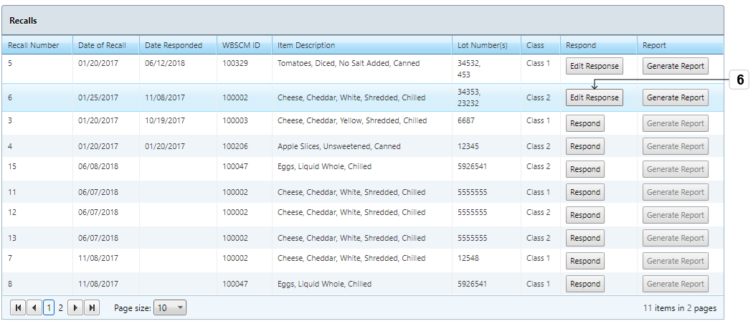
Figure 65 Edit Response Button
- Click Edit Response to edit an existing recall response
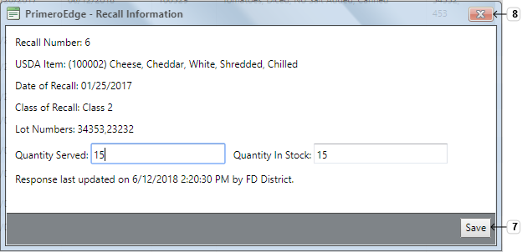
Figure 66 Recall Information
- Make changes and click Save
- Click X to close the view
Generate a Recall Report
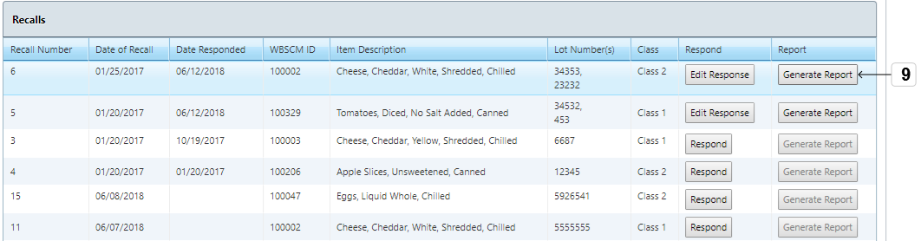
Figure 67 Generate Report Button
- Click Generate Report to view the Recall Record Report
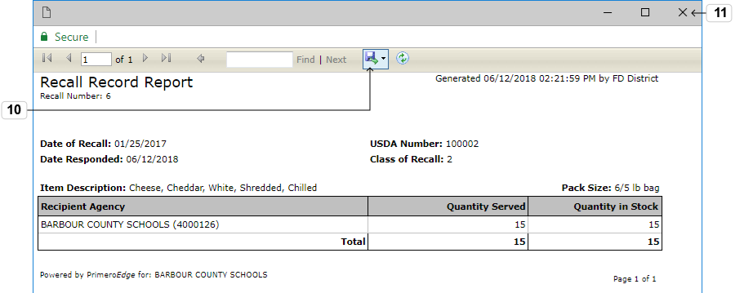
Figure 68 Recall Record Report
- Click the Export icon to export the report in various formats
Exporting as PDF will yield better printing results
- Click X to close the report view

Complaint List
This section contains tasks for managing the Complaint List.
Go to District > Food Distribution > Recalls/Complaints > Complaint List
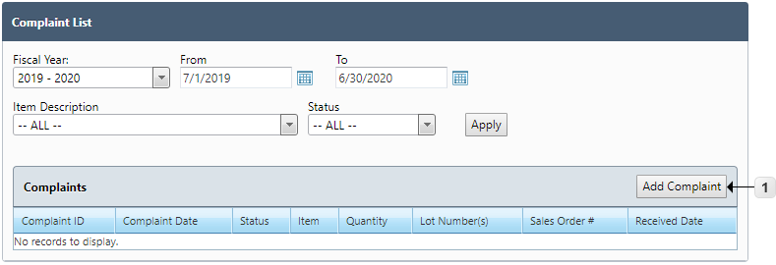
Figure 69 Complaint List
- Click Add Complaint

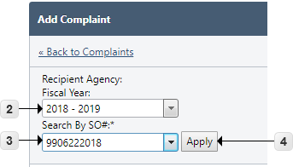
Figure 70 Add Complaint
- Select the Fiscal Year
- Select the Sales Order Number
- Click Apply
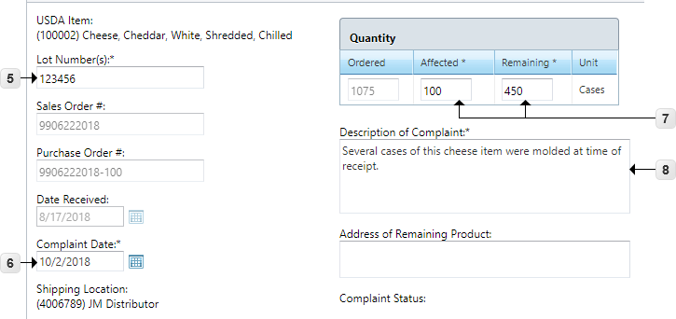
Figure 71 Add Complaint
- Enter the Lot Number(s)
- Select the Complaint Date
- Enter Affected and Remaining Quantity
- Enter Description of Complaint
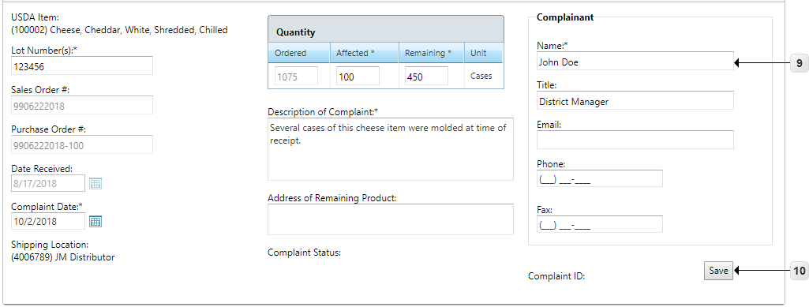
Figure 72 Add Complaint
- Enter Complainant Name
- Click Save
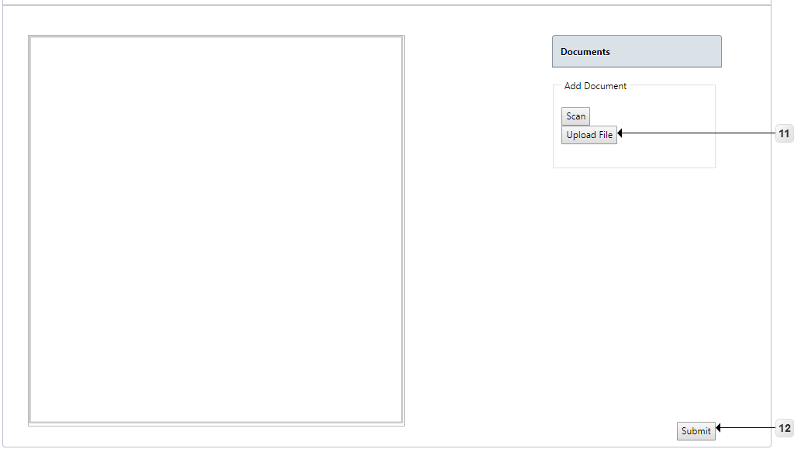
Figure 73 Submit Complaint
- Click Upload File to add attachments
- Click Submit to finalize the Complaint

District—Reports
PrimeroEdge Food Distribution updates reports in real time. Reports include PAL Balances, USDA Item History, Catalog Response, Commodity Perpetual Inventory, Transaction History and Shippers Breakdown.

Orders
This Functional Area contains tasks for generating an Orders Report. The Orders Report provides the current status of all placed orders that have received a Sales Order number and provides updates on the status as they are received.
Go to District > Food Distribution > Reports > Orders
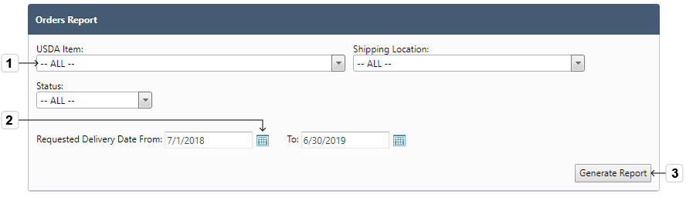
Figure 74 District Orders Report Selections
- Select the USDA Item, Shipping Location, or Status
- Modify Requested Delivery Date range by using the calendar
- Click Generate Report
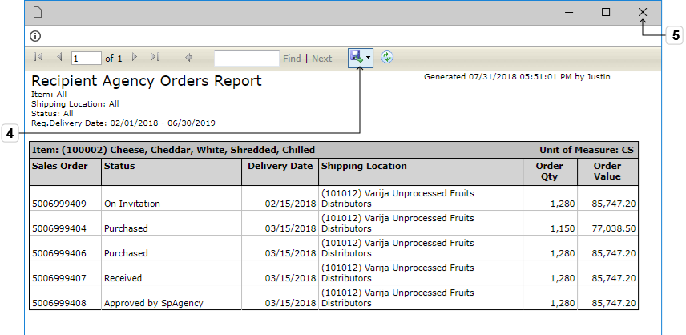
Figure 75 District Orders Report
- Click the Export icon to save the worksheet in one of the optional formats
Exporting as PDF will yield better printing results
- Click the X to close the report view

PAL Balances
This section contains tasks for generating a PAL Balances report. The PAL Balances Report displays a list of transactions that affected the PAL funds balance for the Recipient Agency.
Go to District > Food Distribution > Reports > PAL Balances
Figure 76 District PAL Balances Selections
- Select the Fiscal Year
- Click Generate Report to view the report
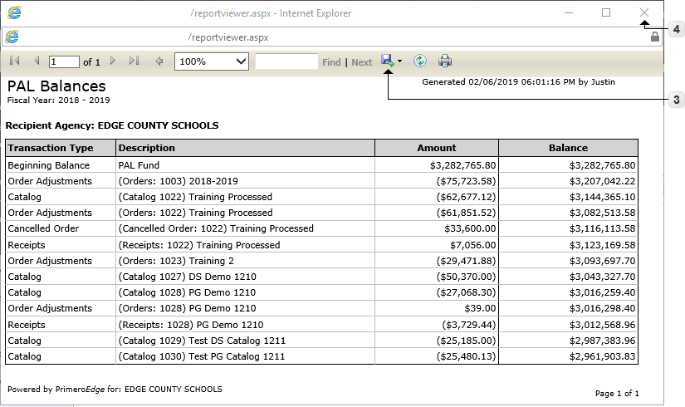
Figure 77 PAL Balances Report
- Click the Export icon to save the worksheet in one of the optional formats
Exporting as PDF will yield better printing results
- Click the X to close the report view

USDA Item History
This section contains tasks for generating a USDA Item History report. The USDA Item History Report provides a historical list of transactions for each item at a selected Shipping Location.
Go to District > Food Distribution > Reports > USDA Item History
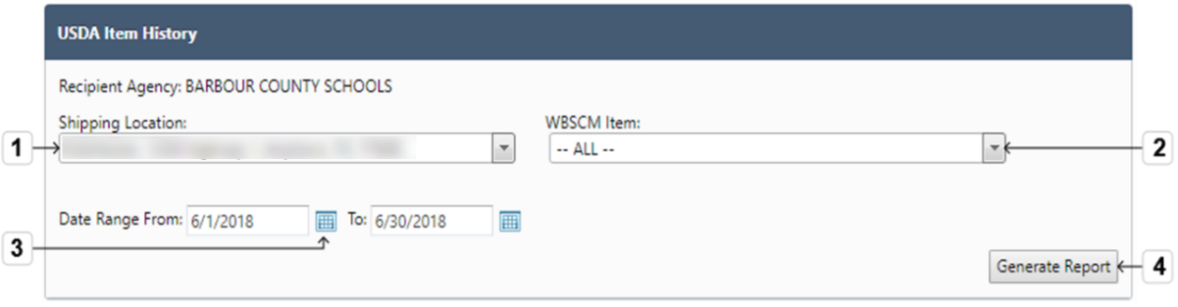
Figure 78 USDA Item History Selections
- Select the Shipping Location
- Select a WBSCM Item
- Use the Calendar to select Date Range
- Click Generate Report
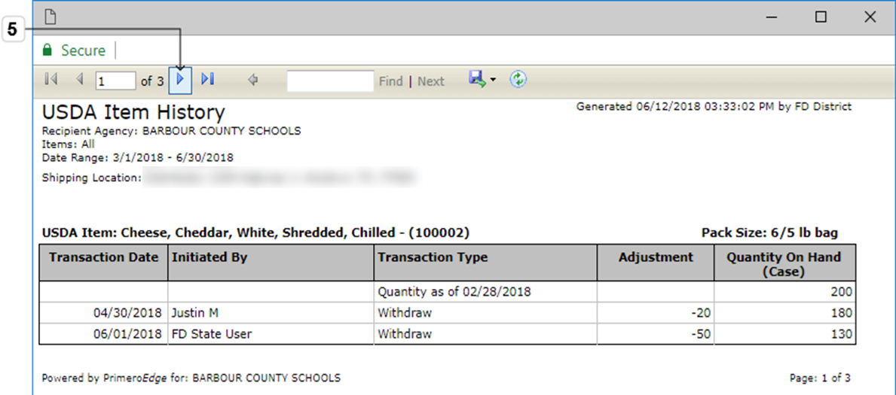
Figure 79 Next Page Control
- Click Next Page to view the different items and their transaction history
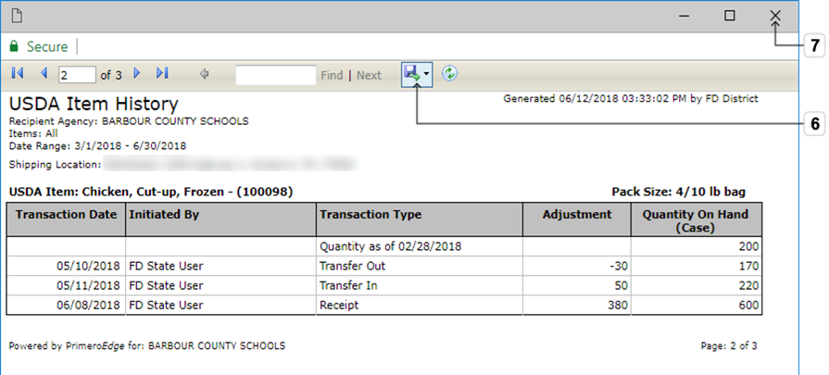
Figure 80 Download Icon
- Click the Export icon to save the worksheet in one of the optional formats
Exporting as PDF will yield better printing results
- Click the X to close the report view

Catalog Response
This section contains tasks for generating a Catalog Response report. The Catalog Response Report displays a page by page summary of the Recipient Agency's responses to catalogs for a Fiscal Year.
Go to District > Food Distribution > Reports > Catalog Response
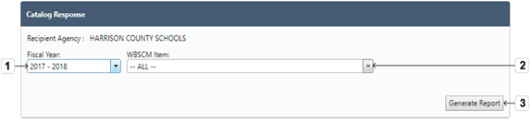
Figure 81 Catalog Response
- Select the Fiscal Year
- Select a WBSCM Item
- Click Generate Report
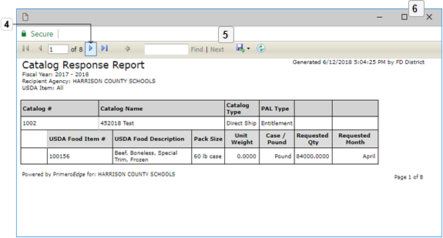
Figure 82 Next Page Control
- Click Next Page to view the different Catalogs
- Click the Export icon to save the worksheet in one of the optional formats
Exporting as PDF will yield better printing results
- Click the X to close the report view

Commodity Perpetual Inventory
This section contains tasks for generating a Commodity Perpetual Inventory Report. The Commodity Perpetual Inventory Report displays all items with quantity on hand at the selected Shipping Location(s).
Go to District > Food Distribution > Reports > Commodity Perpetual Inventory
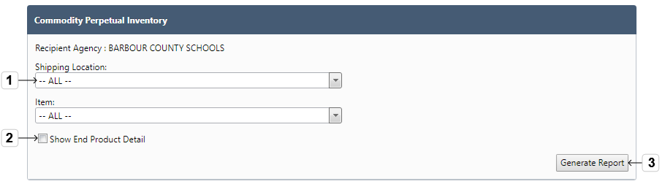
Figure 83 Virtual Inventory
- Select the Shipping location and WBSCM Item
- Click Show End Product Detail to show the sub-grid for any commodity items at a processor that are used to create end products
- Click Generate Report
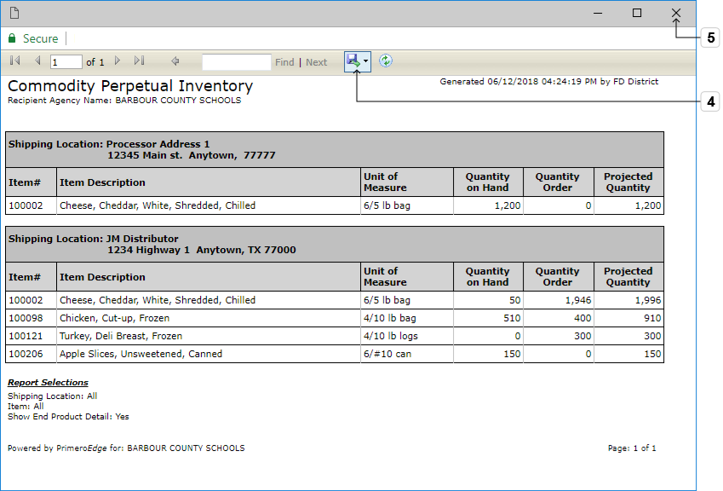
Figure 84 Commodity Perpetual Inventory Report
- Click the Export icon to save the worksheet in one of the optional formats
Exporting as PDF will yield better printing results
- Click the X to close the report view

Transaction History
This section contains tasks for generating a Transaction History report. The Transaction History Report lists all Recipient Agency transactions for a specified date range.
Go to District > Food Distribution > Reports > Transaction History
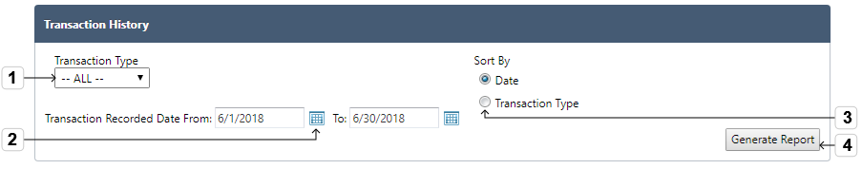
Figure 85 Transaction History
- Select a Transaction Type
- Select Transaction Recorded Date range
- Click applicable Radio to Sort By Date or Transaction Type
- Click Generate Report
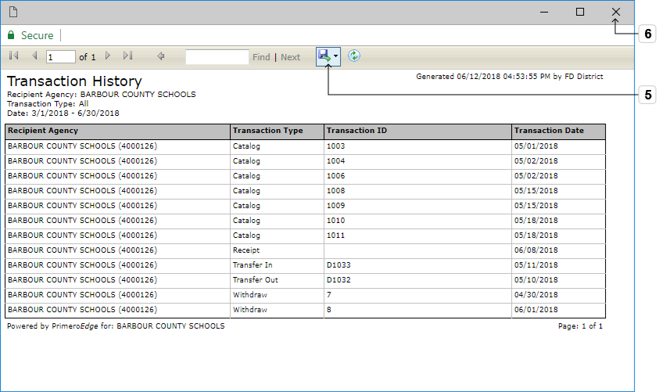
Figure 86 Transaction History Download Control
- Click the Export icon to save the worksheet in one of the optional formats
Exporting as PDF will yield better printing results
- Click the X to close the report view

Shippers Breakdown
This Functional Area contains tasks for generating a Shippers Breakdown Report. The Shippers Breakdown Report provides an item breakdown with RA address for Distributors to use for delivering orders.
Go to District > Food Distribution > Reports > Shippers Breakdown
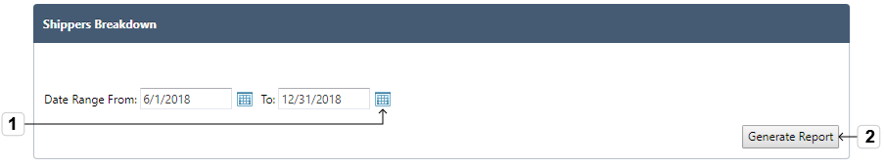
Figure 87 Shippers’ Breakdown Selections
- Select a Date Range
- Click Generate Report
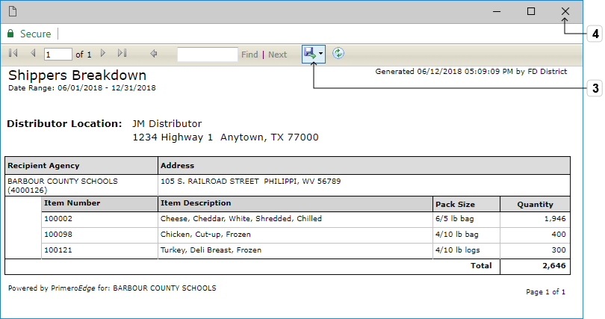
Figure 88 Shippers' Breakdown Report
- Click the Export icon to save the worksheet in one of the optional formats
Exporting as PDF will yield better printing results
- Click the X to close the report view

District—Management
This Category contains tasks for managing Commodity Drawdown, Forms and Planned Assistance Level (PAL) in the District Realm.

Planned Assistance Level
This section contains tasks for managing Planned Assistance Levels. The Planned Assistance Level page allows the district to allocate its PAL funds to the various programs for spending that fiscal year.
Go to District > Food Distribution > Management > Planned Assistance Level
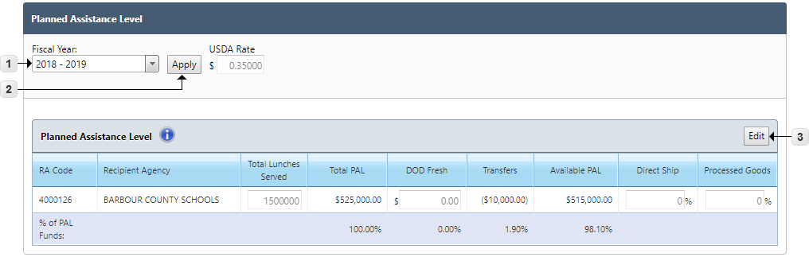
Figure 89 Planned Assistance Level Selections
- Select the Fiscal Year
- Click Apply
- Click Edit
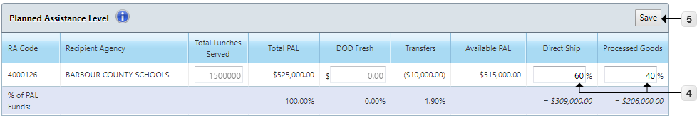
Figure 90 Planned Assistance Level List
- Enter optional Direct Ship and Processed Goods allocation percentages
- Click Save

Commodity Drawdown
This section contains tasks for managing Commodity Drawdown. This page allows the manual drawdown of items with quantity on hand at a processor or distributor location.
Go to District > Food Distribution > Management > Commodity Drawdown
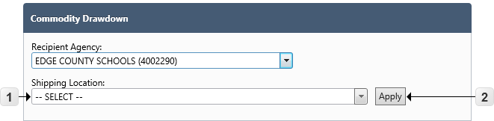
Figure 91 Commodity Drawdown
- Select the Shipping Location
- Click Apply
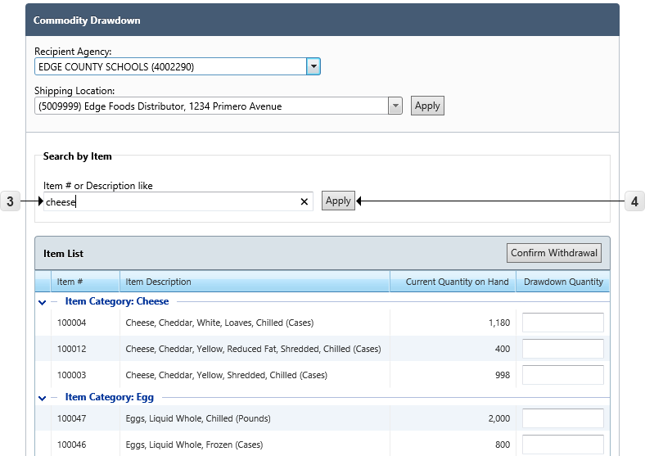
Figure 92 Commodity Drawdown Item Search
- Use the Item Search Box to filter results by Item Number or Item Description
- Click Apply
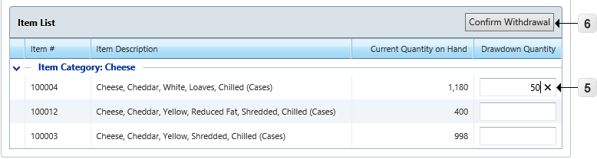
Figure 93 Commodity Drawdown Confirm Withdrawal
- Enter Drawdown Quantity for item(s)
- Click Confirm Withdrawal

Forms
This section contains tasks for managing Forms. The Forms page allows for the upload of district forms and viewing of forms uploaded at the state level.
Go to District > Food Distribution > Management > Forms
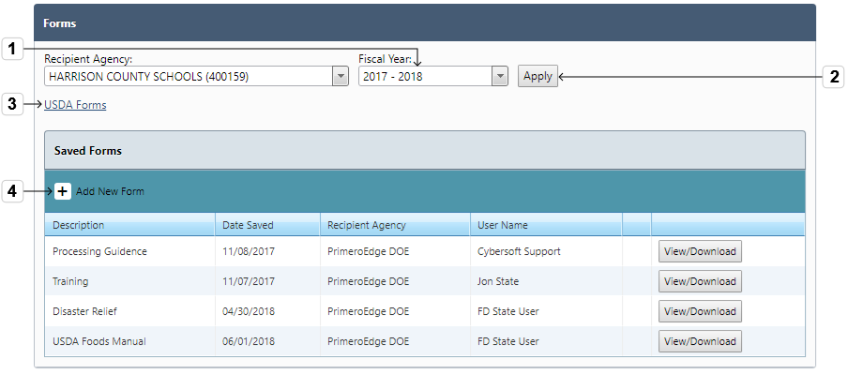
Figure 94 Forms Selections and Saved Forms List
- Select the Fiscal Year
- Click Apply
- Click the USDA Forms hyperlink to open a new window to the external FNS (Food and Nutrition Service) Forms page
- Click Add New Form Plus Sign
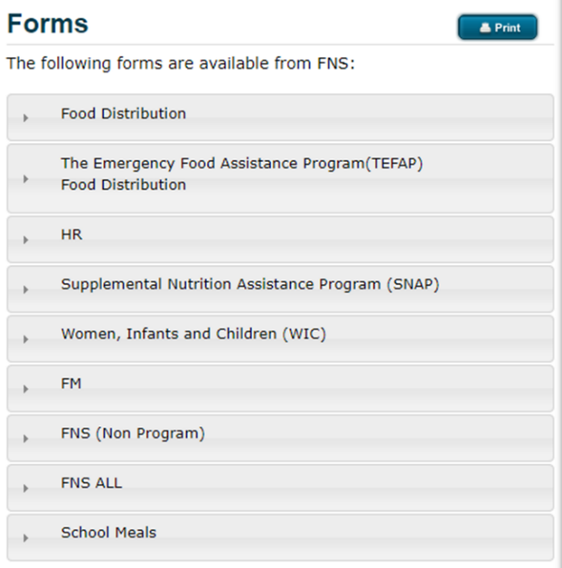
Figure 95 FNS Forms External View
Download these forms directly from the USDA website.
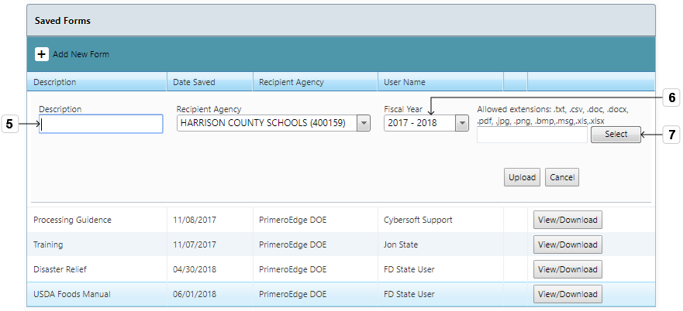
Figure 96 Form Description and Year Selections
- Use text field to enter the Form Description
- Select the Fiscal Year
- Click Select
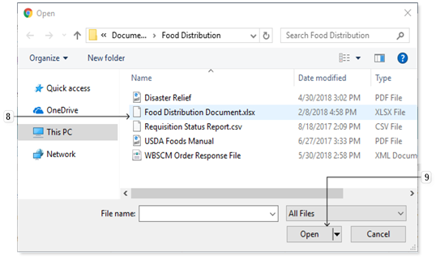
Figure 97 Local Computer Files
- Navigate to the file and select it
- Click Open
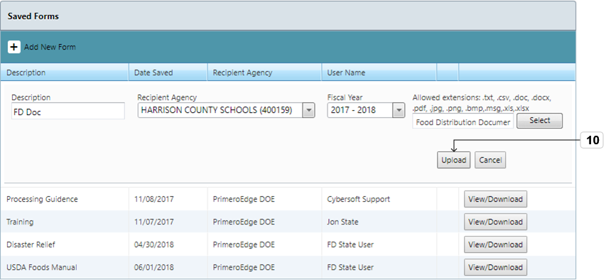
Figure 98 Upload Button
- Click Upload
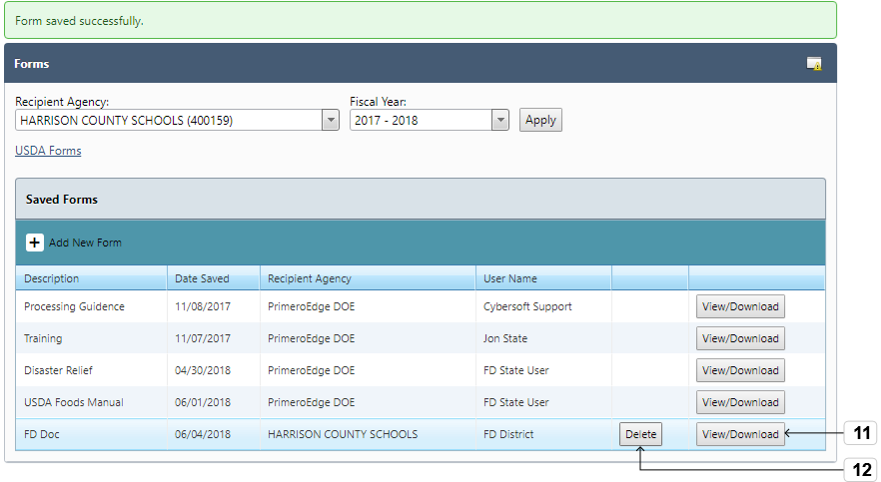
Figure 99 View/Download Button
- Click View/Download to view a form
- Click Delete to remove a form
The Delete button is only available for forms uploaded within the logged-in District.
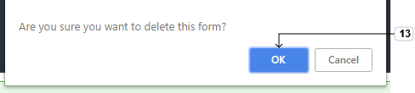
Figure 90 Delete Confirmation Box
- Click OK to confirm deletion

